

**EEC 521 Software Engineering**

Project Report

For

Student Enrollment System

Prepared By,

Uday Shankar Boddupalli (2868122)

Yogeshwar Suresh (2862061)

**1. Introduction**

The **Student Course Enrollment System** is a web-based application designed to simplify and streamline the process of managing course enrollments and administration in educational institutions. It is intended to replace traditional manual enrollment methods with a centralized platform that fosters efficiency, minimizes errors, and enhances the overall user experience for both students and administrators.

* 1. **Purpose and Scope**

The **purpose** of this project is to develop a reliable and user-friendly system that allows students to seamlessly enroll in courses while enabling administrators to manage class details efficiently. The application ensures compliance with predefined academic rules, such as enrollment limits and progress tracking, and integrates automated mechanisms to maintain data integrity.

The **scope** of the project includes:

* **Student Features**:
  + Secure login and authentication.
  + View for available courses.
  + Enroll in courses with real-time seat availability.
  + Track progress and manage active/completed courses.
* **Administrator Features**:
  + Create and manage courses with configurable attributes such as maximum seats, descriptions, and schedules.
  + Monitor student enrollments.
  + Update class details.
* **System Features**:
  + Centralized database to manage users, courses, and enrollments.
  + RESTful APIs to facilitate interaction between the frontend and backend.
  1. **Product Overview**

The **Student Course Enrollment System** offers a robust set of capabilities designed to improve the management of academic courses and student enrollments.

Below are its primary features and scenarios:

**Capabilities:**

1. **Streamlined Enrollment**:
   * Real-time display of available courses with filters for ease of selection.
   * Automatic seat availability checks to ensure students can only enroll in valid courses.
2. **Centralized Management**:
   * Admins can efficiently create and update course details and manage enrollments through a structured interface.
   * Triggers and data integrity checks ensure that updates to records are consistently logged and validated.
3. **Compliance Assurance**:
   * Automatic restrictions on exceeding active enrollment limits (maximum three classes per student).
   * Prevention of duplicate enrollments and full-class registrations.
4. **User-Friendly Design**:
   * Intuitive interfaces powered by React.js and styled with Chakra UI for consistent and accessible user experiences.
   * Modals and collapsible components enhance interaction for admins and students.

**Scenarios for Using the Product:**

1. **For Students**:
   * Enroll in courses such as "Math 101" or "Biology 202" for the upcoming semester.
   * Track active courses and monitor progress.
2. **For Administrators**:
   * Manage the creation of a new course titled "Data Structures and Algorithms," setting maximum seats and assigning an instructor.
   * Monitor enrollments for a specific class, such as "Physics 201," to ensure no oversubscription.
   1. **Structure of the Document**

This document is organized to provide a comprehensive overview of the project, its functionalities, and its implementation. Each section elaborates on a specific aspect of the system:

1. **System Design**:
   * Describes the architecture, including database schema and layered design for the backend.
   * Explains the integration of React frontend with the .NET Core API backend.
2. **Development Process**:
   * Details on backend and frontend implementation, database setup, and deployment.
3. **Testing**:
   * Summarizes test cases and results to validate the functionality and performance.
4. **Conclusion and Recommendations**:
   * Highlights achievements, discusses challenges faced, and proposes future enhancements.
   1. **Terms, Acronyms, and Abbreviation**

This section defines terms and acronyms frequently used throughout the document:

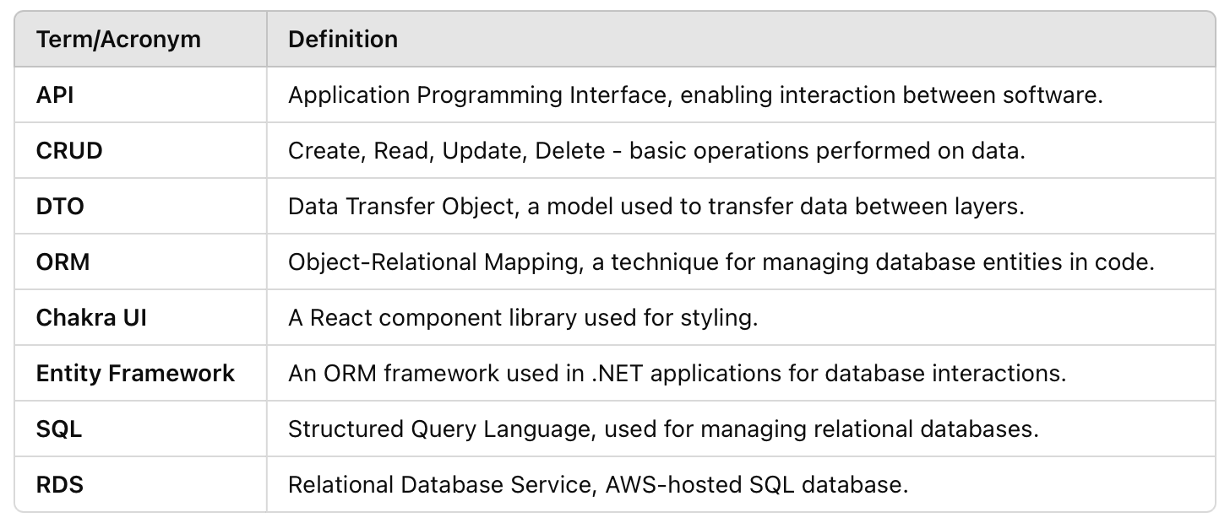

1. **Project Management Plan**

The **Student Course Enrollment System** project was managed systematically, following well-defined roles, methodologies, and timelines. This section outlines the organizational structure, the lifecycle model employed, risk analysis, resource requirements, and the deliverables schedule.

* 1. **Project Organization**

The project was collaboratively developed by **two developers**, each with distinct responsibilities and deliverables:

1. **Uday Shankar**:
   * **Roles**:
     + Backend Developer: Responsible for designing and implementing the backend using .NET Core and integrating the database with Entity Framework.
     + Database Manager: Designed database schemas, implemented data relationships, and ensured consistency via triggers.
     + Documentation Specialist: Authored the **Developer’s Guide** (backend and database sections) and the **Project Report**.
   * **Key Contributions**:
     + Implemented API controllers for managing students, enrollments, and courses.
     + Created and optimized database scripts to ensure data integrity and consistency.
2. **Yogeshwar Suresh**:
   * **Roles**:
     + Frontend Developer: Built the frontend using React with Chakra UI for styling and implemented dynamic UI components.
     + User Experience Specialist: Focused on creating a user-friendly interface for students and admins.
     + Documentation Specialist: Authored the **Developer’s Guide** (frontend sections) and the **User Manual**.
   * **Key Contributions**:
     + Developed pages for login and dashboard functionalities, integrating them with backend APIs.
     + Enhanced usability by implementing modals, pagination, and responsive UI design.

**Collaboration Strategy**:

* The team coordinated via regular progress updates and shared development tasks based on their areas of expertise.
* Testing and debugging were collaborative efforts to ensure the seamless integration of frontend and backend components.
  1. **Lifecycle Model Used – Waterfall Model**

The **Waterfall Model** was chosen for its structured and sequential approach, aligning well with the project’s clearly defined scope and requirements.

**Phases of Development:**

1. **Requirement Analysis**:
   * Gathered and documented requirements for student and admin functionalities.
   * Created user stories and defined key use cases, such as enrollment, course management
2. **System Design and Planning**:
   * Defined a layered architecture, including controllers, services, and data models for the backend.
   * Designed the UI wireframes and database schemas, ensuring all components aligned with project goals.
3. **Implementation**:
   * Backend and database development were handled by Uday, while Yogesh focused on building the frontend.
   * APIs and UI components were integrated iteratively, with rigorous testing at each stage.
4. **Testing**:
   * Conducted manual testing based on predefined test cases to validate functionalities and ensure system reliability.
5. **Deployment**:
   * The project was deployed locally, with a focus on delivering a fully functional product for testing and demonstration.
6. **Maintenance**:
   * Provided documentation for developers and users to ensure long-term maintainability.

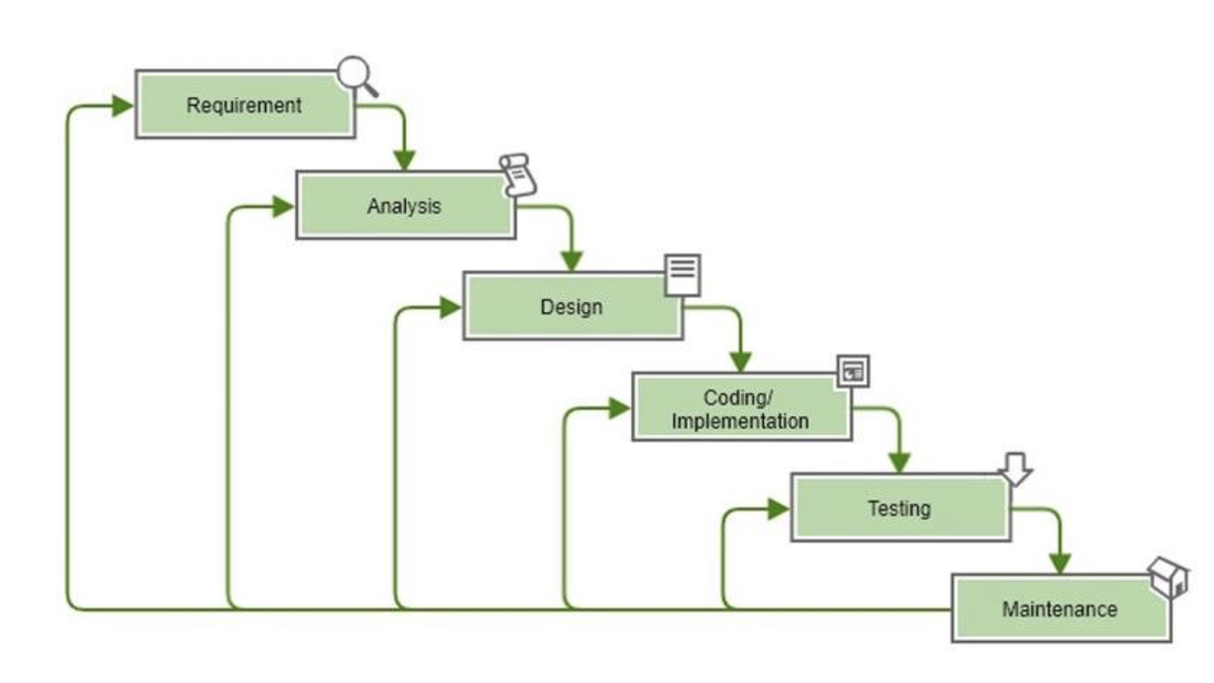

**2.3. Risk Analysis**

The team identified potential risks during the project and implemented mitigation strategies to ensure smooth progress:

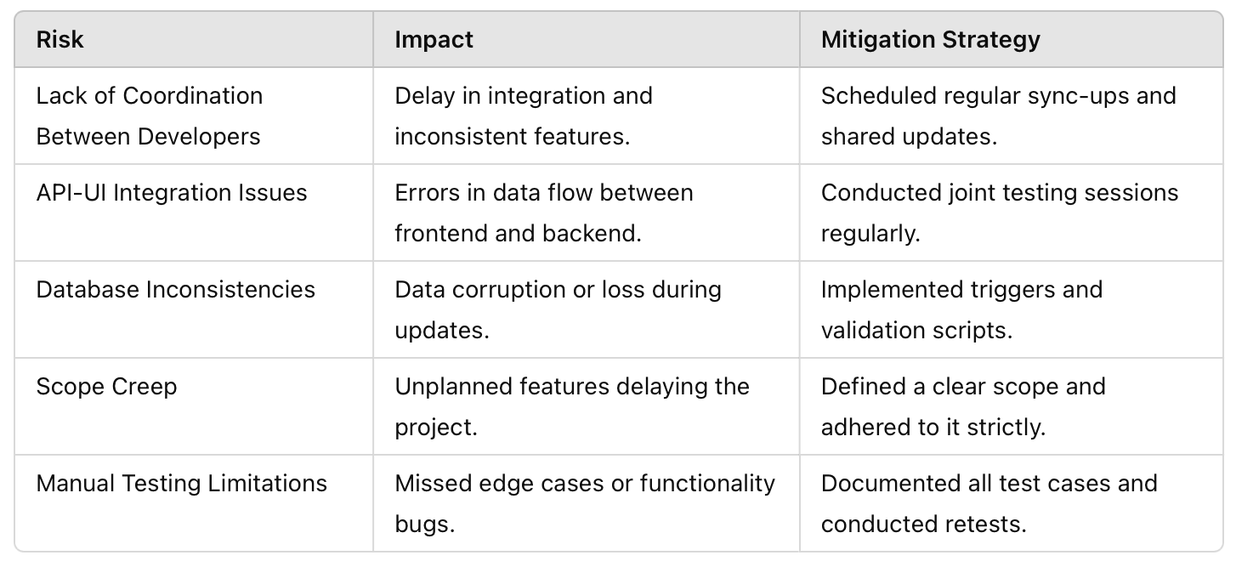

* 1. **Hardware and Software Resource Requirements**

**Hardware Requirements:**

* **Developer Machines**:
  + Processor: Intel i5 or higher.
  + RAM: Minimum 8 GB.
  + Storage: 500 GB SSD.

**Software Requirements:**

1. **Backend**:
   * .NET 8 Framework.
   * Entity Framework Core 7.
   * SQL Server Management Studio for database management.
2. **Frontend**:
   * React.js 18.
   * Node.js for running the frontend.
   * Chakra UI for styling components.
3. **Development Tools**:
   * Visual Studio Code for coding.
   * Postman for API testing.
   * Git for version control.
4. **Testing Environment**:
   * Supported browsers: Chrome, Firefox, Safari.
   * Manual testing setup with test cases documented in spreadsheets.











* 1. **Deliverables and Schedule**

The following deliverables were produced based on the timeline outlined in the **Software Test**

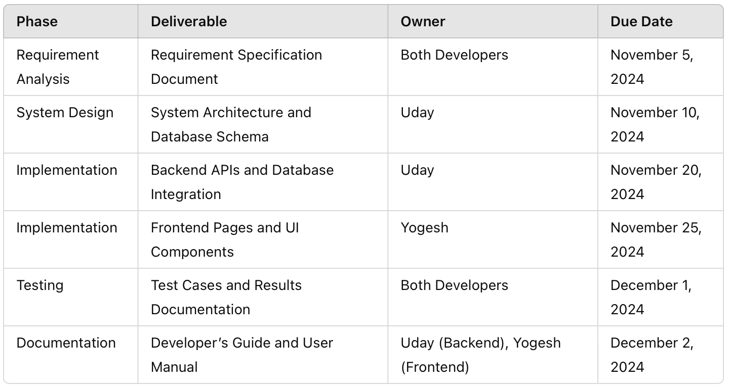

1. **Requirement Specifications**

This section outlines the stakeholders involved in the **Student Course Enrollment System**, key use cases describing the system's functionality, the rationale behind the use case model, and the non-functional requirements that ensure system quality.

* 1. **Stakeholders for the System**

The primary stakeholders of the system are:

1. **Students**:
   * They are the End-users who log in to the system to view available courses, enroll in them, and track their progress.
2. **Administrators**:
   * They are the End-users responsible for managing the courses, monitoring enrollments, and ensuring compliance with academic regulations.
3. **Educational Institution**:
   * The organization that implements and benefits from the system.
4. **Development Team**:
   * Developers and maintainers of the system.
   * A maintainable, scalable, and well-documented system.
5. **Testing Team**:
   * Ensures the system meets the specified functional and non-functional requirements.
   1. **Use Cases**

**Use Case 1: Student Login**

* **Actors**: Student.

**Textual Description**:

1. The student navigates to the login page.
2. They input their email and password in the respective fields.
3. On clicking "Login," the system validates the credentials by querying the database.
4. If valid, the student is redirected to the dashboard. If invalid, an error message is displayed.
5. The system records the login time and updates the session.

**Use Case 2: View Available Classes**

* **Actors**: Student.

**Textual Description**:

1. The student navigates to the "Available Classes" section in the dashboard.
2. The system retrieves and displays all classes with details such as:
   * Course Name.
   * Description.
   * Start and End Dates.
   * Maximum and Current Seats.
3. The student can use the search bar to find specific classes by keyword or filter them by category.
4. If no classes are available, the system displays an appropriate message.

**Use Case 3: Enroll in a Class**

* **Actors**: Student.

**Textual Description**:

1. The student selects a course from the list of available classes.
2. They click the "Enroll" button.
3. The system checks:
   * If the course has available seats.
   * If the student is already enrolled in three active classes.
   * If the student is not already enrolled in the selected course.
4. If all checks pass:
   * The system records the enrollment in the database.
   * The seat count for the course is updated.
5. A confirmation message is displayed. If any check fails, an error message is shown.

**Use Case 4: Create a New Class**

* **Actors**: Administrator.

**Textual Description**:

1. The admin navigates to the "Create Class" section in the dashboard.
2. They fill in the following details:
   * Class Name.
   * Description.
   * Start and End Dates.
   * Maximum Seats.
3. On submission:
   * The system validates the inputs (e.g., no duplicate names, valid seat limits).
   * If valid, the system saves the new class in the database.
4. The system displays a success message, and the new class becomes available for students.

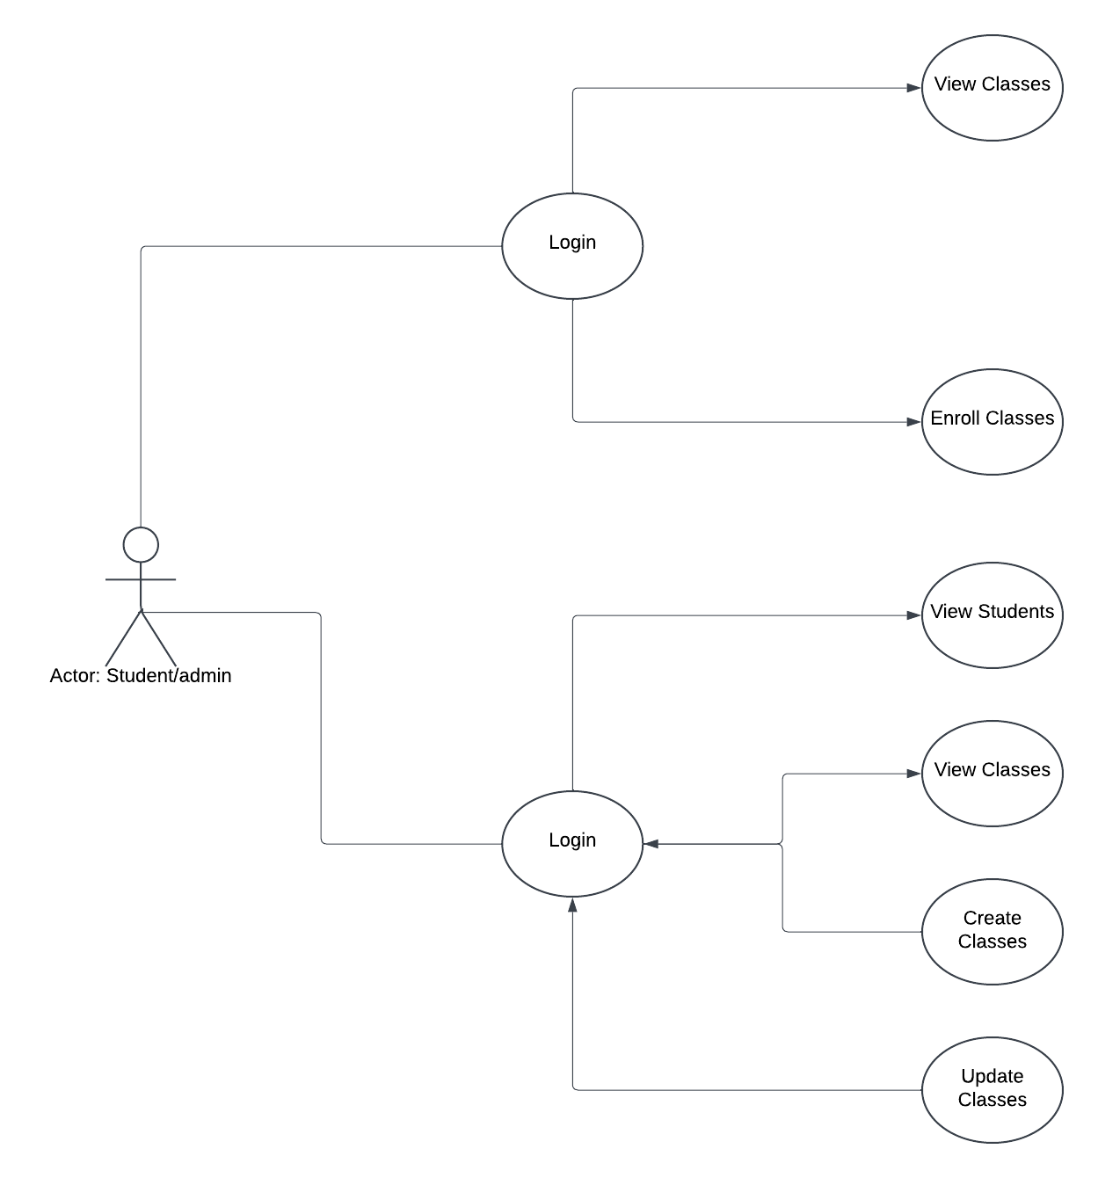**3.2.1 Use Case Diagram**

* 1. **Non-Functional Requirements**

The non-functional requirements of the system address quality attributes and operational constraints to ensure the application is robust and user-friendly:

1. **Performance:**
   * The system should handle up to 100 concurrent users without latency exceeding 2 seconds per operation.
   * Enrollment operations should update the database within 1 second.
2. **Scalability:**
   * The system should support the addition of new features, such as notifications or advanced reporting, without requiring major architectural changes.
3. **Reliability:**
   * Data consistency must be maintained during all operations, including updates and deletions.
   * Downtime should not exceed 1 hour per month for maintenance.
4. **Security:**
   * User credentials must be encrypted using industry-standard algorithms.
   * Access control must prevent unauthorized users from viewing or modifying sensitive data.
5. **Usability:**
   * The user interface must be intuitive, with clear navigation and error messages.
   * The application should be fully responsive and compatible with all major browsers.
6. **Maintainability:**
   * The system should include well-documented code and comprehensive guides for developers and users.
   * Database triggers and validation scripts should be reusable and easily modifiable.
7. **Portability:**
   * The system must be deployable on any cloud platform or local server with minimal configuration.
8. **Compliance:**
   * The system must adhere to relevant educational and data protection standards.
9. **Architecture**

The architecture of the **Student Course Enrollment System** is a foundational element that ensures scalability, maintainability, and efficiency. This section details the architectural styles used, the model with components and interactions, the technologies and resources employed, and the rationale behind the chosen architecture.

**4.1. Architectural Style(s) Used**

The system adopts a **Layered Architecture** style, commonly used in enterprise applications, along with the **Client-Server Model**.

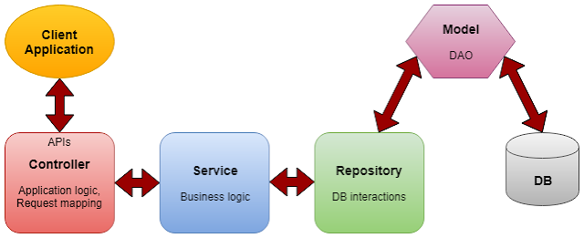

The **Layered Architecture** is a design paradigm that divides an application into distinct layers, each responsible for specific functionalities. This separation ensures modularity, making it easier to develop, test, and maintain the system.

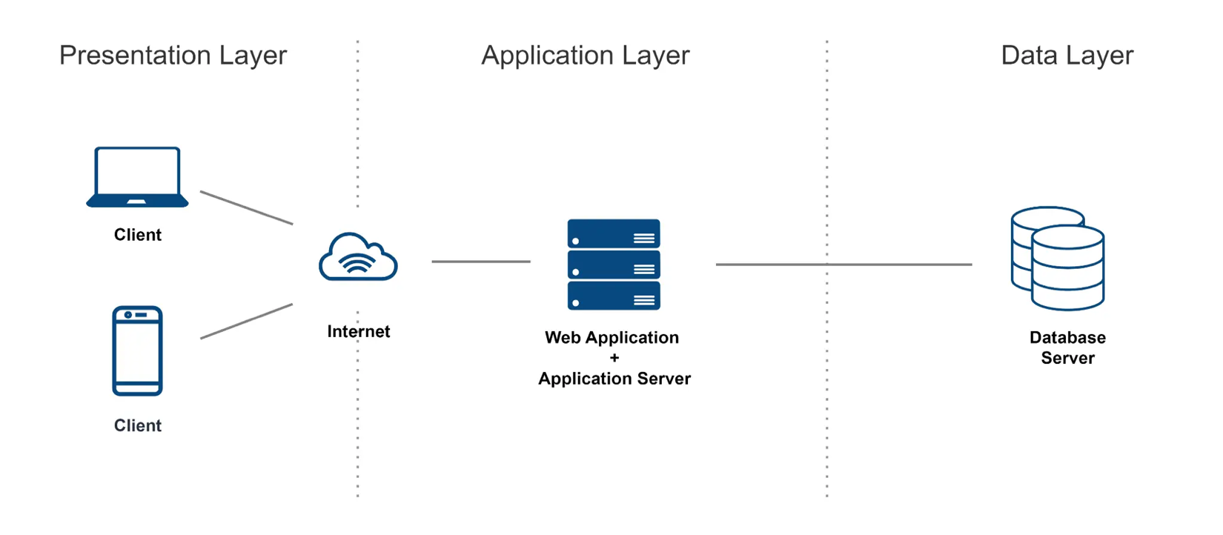

**In the Student Course Enrollment System, the architecture includes four main layers:**

1. **Presentation Layer (Frontend):**
   * Provides the user interface (UI) for interacting with the system.
   * Built with React.js, this layer includes components like **Login.tsx** and **Dashboard.tsx** for user-specific tasks (e.g., login, viewing courses).
   * Communicates with the backend via RESTful APIs.
2. **Business Logic Layer:**
   * Encapsulates the application's core functionalities, such as course enrollment rules, validation of seat availability, and role-based access control.
   * Implemented using ASP.NET Core services to ensure the backend logic is reusable and isolated from the UI.
3. **Data Access Layer:**
   * Manages interactions with the database using Entity Framework Core.
   * Includes repository patterns for accessing tables like Users, Courses, and Enrollments.
4. **Database Layer:**
   * Stores and retrieves data using MS SQL Server.
   * Implements triggers and constraints for ensuring data consistency and integrity.

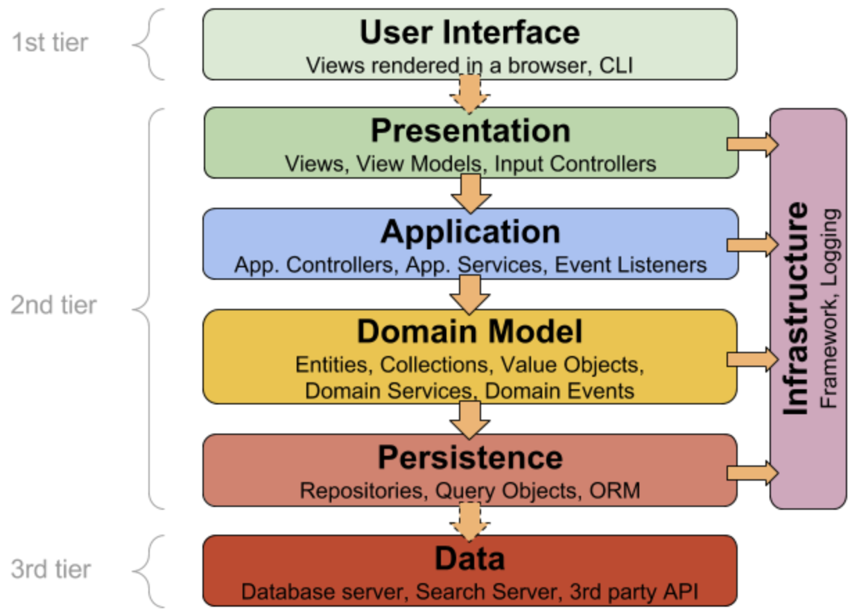

**Benefits of Layered Architecture:**

* Separation of Concerns: Each layer is independent, making the system easier to understand and modify.
* Scalability: New layers or modules (e.g., reporting or notification services) can be added without affecting the existing structure.
* Reusability: Common functionality (e.g., authentication) can be reused across multiple UI components or workflows.
* Maintainability: Debugging and testing are streamlined as developers can focus on a single layer at a time.

**Client-Server Model**

The Client-Server Model is a distributed application structure that separates the application into two distinct entities: the client and the server. The Student Course Enrollment System adheres to this model, where:

* Client: The React frontend acts as the client, responsible for presenting data to users and capturing user inputs. It sends HTTP requests to the server for processing and receives responses to update the UI.
* Server: The ASP.NET Core backend serves as the server, handling the business logic, data processing, and database interactions.

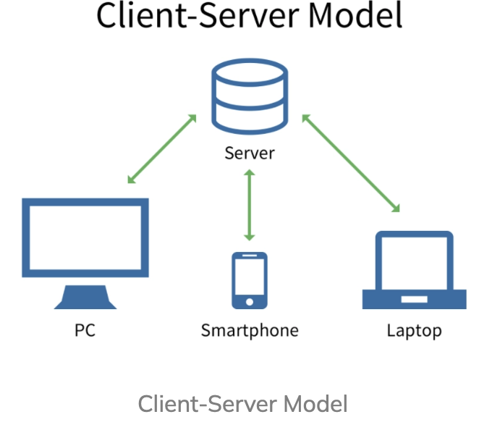

**Detailed Breakdown of the Client-Server Model:**

**1. Client (Frontend):**

* **Role:**
  + Initiates requests for data or actions, such as logging in, viewing available courses, or enrolling in a class.
  + Renders the response data (e.g., list of courses) in a user-friendly interface.
* **Components:**
  + React components (e.g., Login.tsx, Dashboard.tsx).
  + Axios library for making HTTP requests to the backend server.
  + Chakra UI for styling and responsive design.
* **Example Workflow:**
  + A student logs in by entering their email and password.
  + The frontend sends an HTTP POST request to the server’s /api/Students/Login endpoint.
  + Based on the server's response (success or error), the frontend updates the UI (e.g., redirect to the dashboard or show an error message).

**2.Server (Backend):**

* **Role:**
  + Processes client requests by executing the business logic.
  + Interacts with the database to fetch or update data.
  + Sends responses to the client, formatted as JSON objects.
* **Components:**
  + ASP.NET Core controllers (e.g., StudentsController, CourseController).
  + Services to encapsulate the business logic (e.g., checking seat availability during enrollment).
  + Entity Framework Core to handle database queries.
* **Example Workflow:**
  + The server receives a request from the client to fetch all available courses (GET /api/Courses).
  + The backend queries the Courses table in the database.
  + The server sends a JSON response containing the list of available courses to the client.

**3. Communication Between Client and Server:**

* **Protocol:** The system uses the HTTP protocol for communication**.**
* **Request-Response Model:**
  + The client sends an HTTP request (e.g., POST, GET, PUT, or DELETE) to the server.
  + The server processes the request, performs the necessary operations (e.g., querying the database, executing business logic), and sends an HTTP response back to the client.

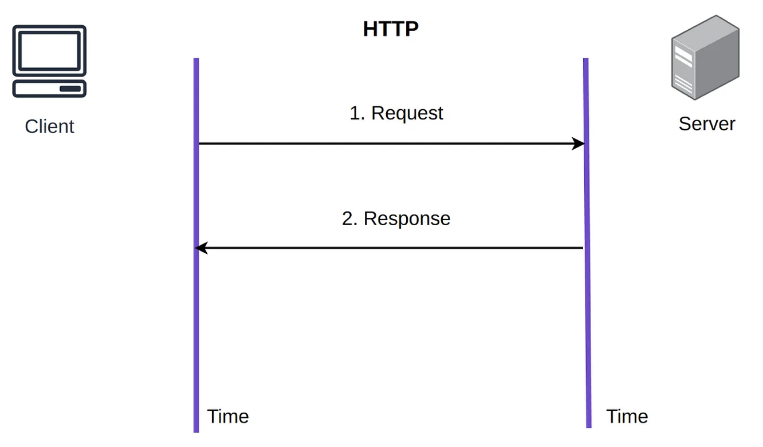

**4. Advantages of the Client-Server Model:**

1. **Scalability**:
   * The server can handle multiple clients simultaneously.
   * Servers can be scaled horizontally to handle higher loads.
2. **Flexibility**:
   * The client (frontend) and server (backend) can evolve independently.
   * Multiple clients (e.g., mobile apps, desktop applications) can connect to the same server.
3. **Security**:
   * Sensitive operations (e.g., authentication, data validation) are handled on the server side, reducing the attack surface on the client.
4. **Centralized Control**:
   * Data and business logic are centralized on the server, ensuring consistency and ease of updates.
5. **Cross-Platform Support**:
   * The client and server communicate over HTTP, making the system accessible from various devices and platforms.

**4.2. Architectural Model**

The **architectural model** describes the components of the system and their interactions, illustrating how data flows between different parts.

**Components and Their Interactions:**

1. **Frontend (React)**:
   * **Components**:
     + Login.tsx: Handles user authentication.
     + Dashboard.tsx: Displays user-specific data (e.g., courses and enrollments).
   * **Interactions**:
     + Sends HTTP requests to the backend API for operations like login, course fetching, and enrollment.

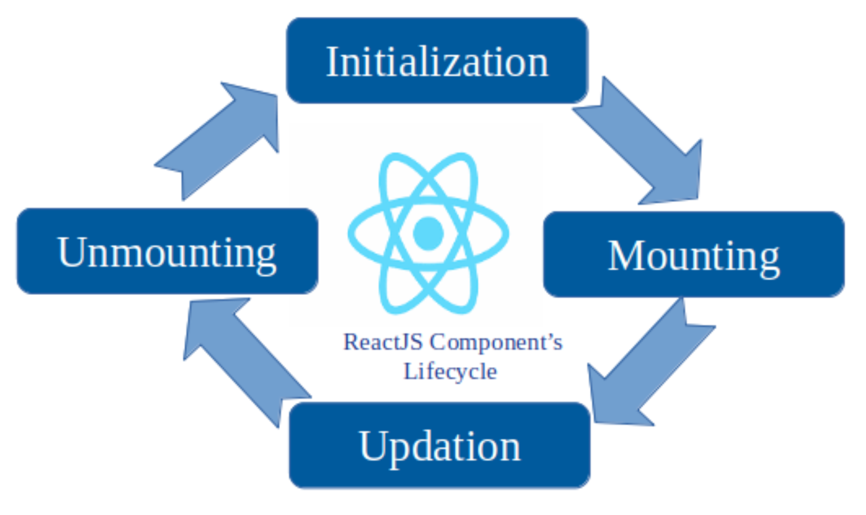

1. **Backend (ASP.NET Core Web API)** **with CLEAN Architecture:**

This application is developed using the CLEAN architecture. Clean architecture has a domain layer, Application Layer, Infrastructure Layer, and Framework Layer. The domain and application layer are always the center of the design and are known as the core of the system. The core will be independent of the data access and infrastructure concerns.

**Benefit of this style:**

1. Independent of frameworks
2. Testable
3. Independent of UI
4. Independent of database
5. Independent of anything external

**Components:**

* + **Controllers**:
    - StudentsController: Manages student-specific operations like login and profile retrieval.
    - CourseController: Handles course management, including creation and updates.
    - EnrollmentsController: Manages enrollment processes and validations.
  + **Services**:
    - Implements business logic, such as enrollment validation and seat availability checks.
  + **Interactions**:
    - Receives requests from the frontend, processes them, and interacts with the database.

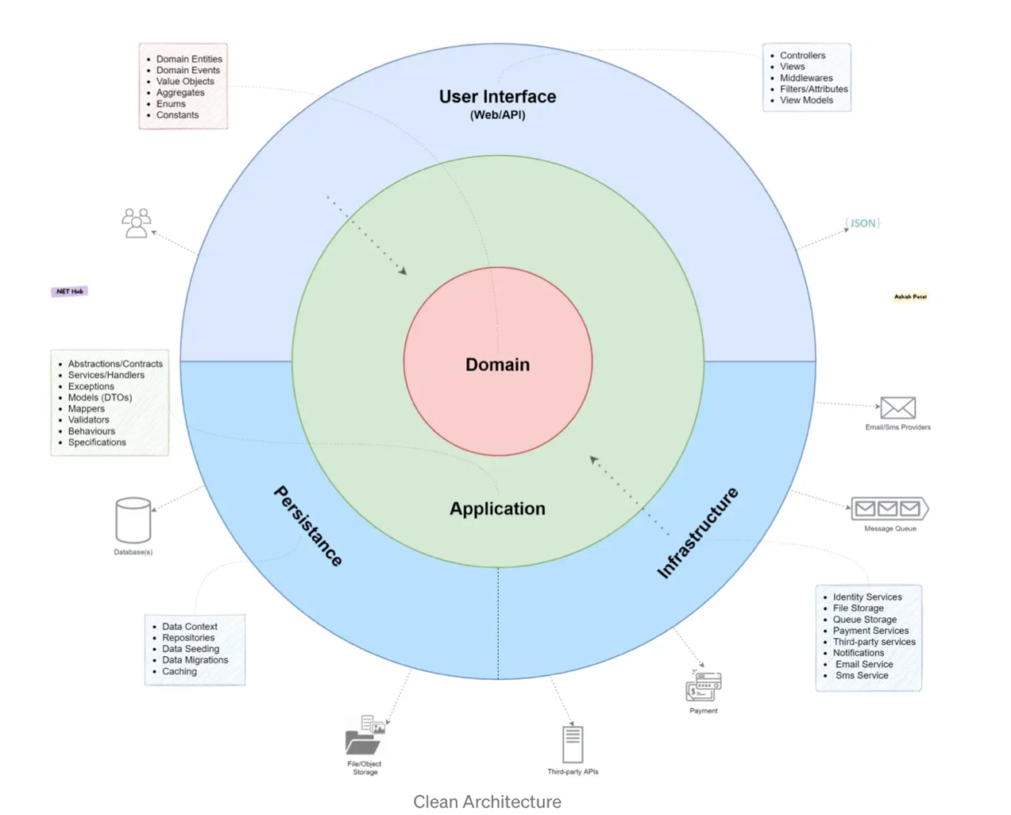

1. **Database (MS SQL Server)**:
   * **Tables**:
     + Users: Stores admin and student data.
     + Courses: Holds information about available classes.
     + Enrollments: Tracks student enrollments and progress.
   * **Triggers**:
     + Ensure data consistency by logging updates and deletions.
   * **Interactions**:
     + Handles queries and updates from the backend, maintaining data integrity.

**4.3. Technology, Software, and Hardware Used**

**Technology Stack:**

1. **Frontend**:
   * React.js 18: For building a responsive and dynamic UI.
   * Chakra UI: For consistent styling and theming.
   * Axios: For handling HTTP requests.
2. **Backend**:
   * ASP.NET Core 8: For implementing RESTful APIs.
   * Entity Framework Core 7: For database interactions using an ORM.
3. **Database**:
   * MS SQL Server 2022: Hosted on AWS RDS for relational data storage.
   * Triggers: Implemented to ensure data integrity and logging.
4. **Version Control**:
   * GitHub: For managing source code with dedicated branches for the frontend and backend.
5. **Testing**:
   * Postman: For API testing.
   * Manual testing tools: Used for validating the frontend and backend functionalities.

**Hardware Requirements:**

* Developer Machines:
  + Processor: Intel i5 or higher.
  + RAM: Minimum 8 GB.
  + Storage: 500 GB SSD.
* Hosting:
  + AWS RDS for database hosting.
  + Localhost for development and testing.

**4.4. Reason for Choosing this Style:**

The choice of architecture and technologies was driven by the project’s requirements, scalability needs, and maintainability goals. Below are the reasons for selecting the layered architecture and client-server model:

**Layered Architecture:**

1. **Separation of Concerns**:
   * Each layer has a distinct responsibility, making the system easier to understand and modify.
   * Changes in one layer (e.g., UI redesign) do not affect others (e.g., database logic).
2. **Reusability**:
   * Business logic and data access components can be reused in future projects or extended without impacting the presentation layer.
3. **Maintainability**:
   * The modular structure allows for easier debugging and testing, as issues can be isolated to a specific layer.
4. **Scalability**:
   * The architecture supports the addition of new layers or features, such as reporting or notifications, without significant refactoring.

**Client-Server Model:**

1. **Flexibility**:
   * The clear separation between client and server allows the frontend and backend to evolve independently.
   * The system can easily integrate with mobile apps or third-party tools in the future.
2. **Scalability**:
   * The server can be scaled horizontally to handle increased user loads, while the client remains lightweight.
3. **Security**:
   * Sensitive operations, such as authentication and enrollment validation, are managed on the server side, reducing exposure to vulnerabilities.

**Technology Choices:**

1. **React and Chakra UI**:
   * These technologies were chosen for their ability to create a responsive and visually appealing user interface quickly.
2. **ASP.NET Core and Entity Framework**:
   * ASP.NET Core provides a robust framework for building APIs, while Entity Framework simplifies database interactions, reducing development time.
3. **MS SQL Server on AWS RDS**:
   * A reliable and scalable database solution ensures high availability and consistent performance.

**5.1. User Interface Design**

The user interface (UI) for the system is designed to be intuitive, responsive, and role-specific, providing seamless interaction for both **students** and **administrators**.

**Key Design Elements:**

1. **Login Page**:
   * Features fields for email and password, styled with Chakra UI components.
   * Includes real-time feedback for incorrect login attempts.
   * Displays a dynamic date and time section for user context.

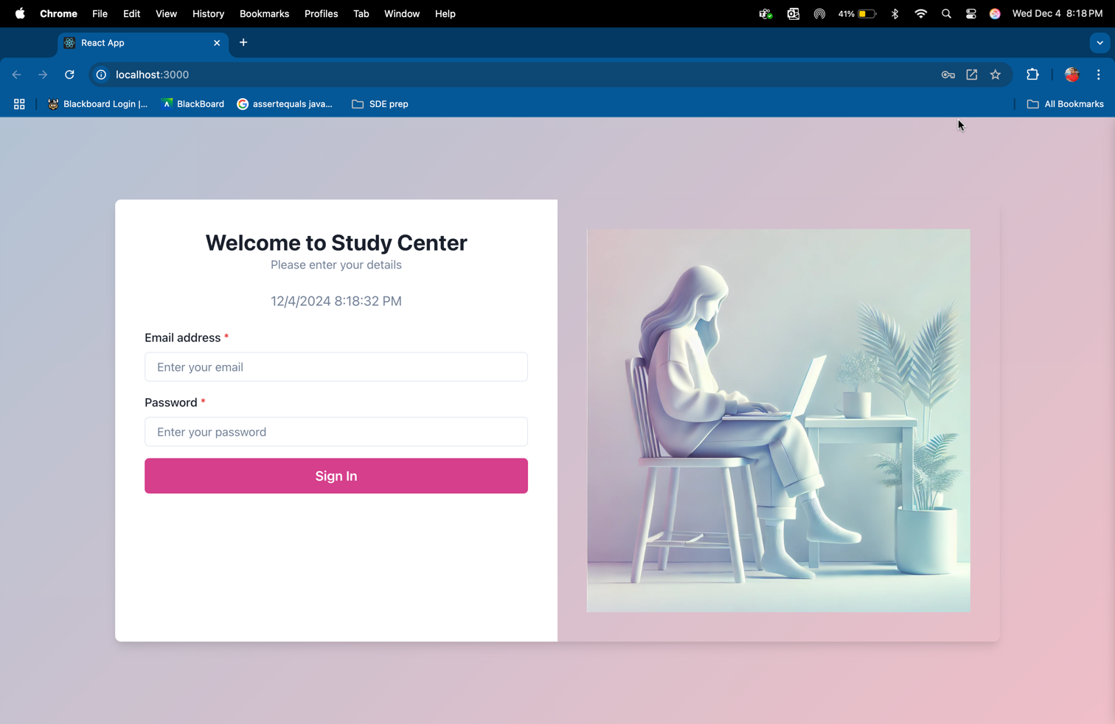

1. **Dashboard for Students**:
   * **Active and Completed Classes**: Displayed in a card layout, showing the status of enrolled courses.
   * **Available Classes**: Presented as filterable table, allowing students to view details and enroll.
   * **Logout Button**: Provides a clear mechanism to end the session.

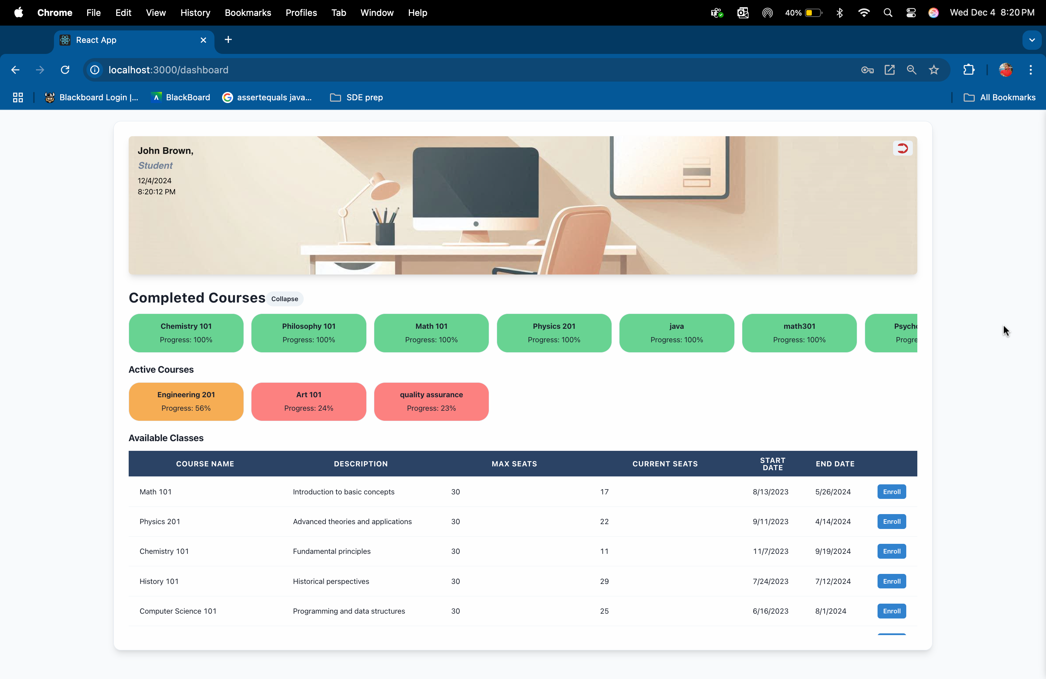

1. **Dashboard for Administrators**:
   * **Student List**: Shows all students and their enrollment statuses.
   * **Course Management**: Edit Course Image
   * 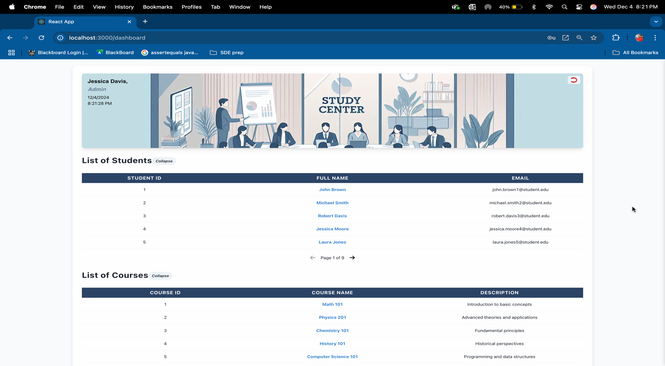**Create Courses:**

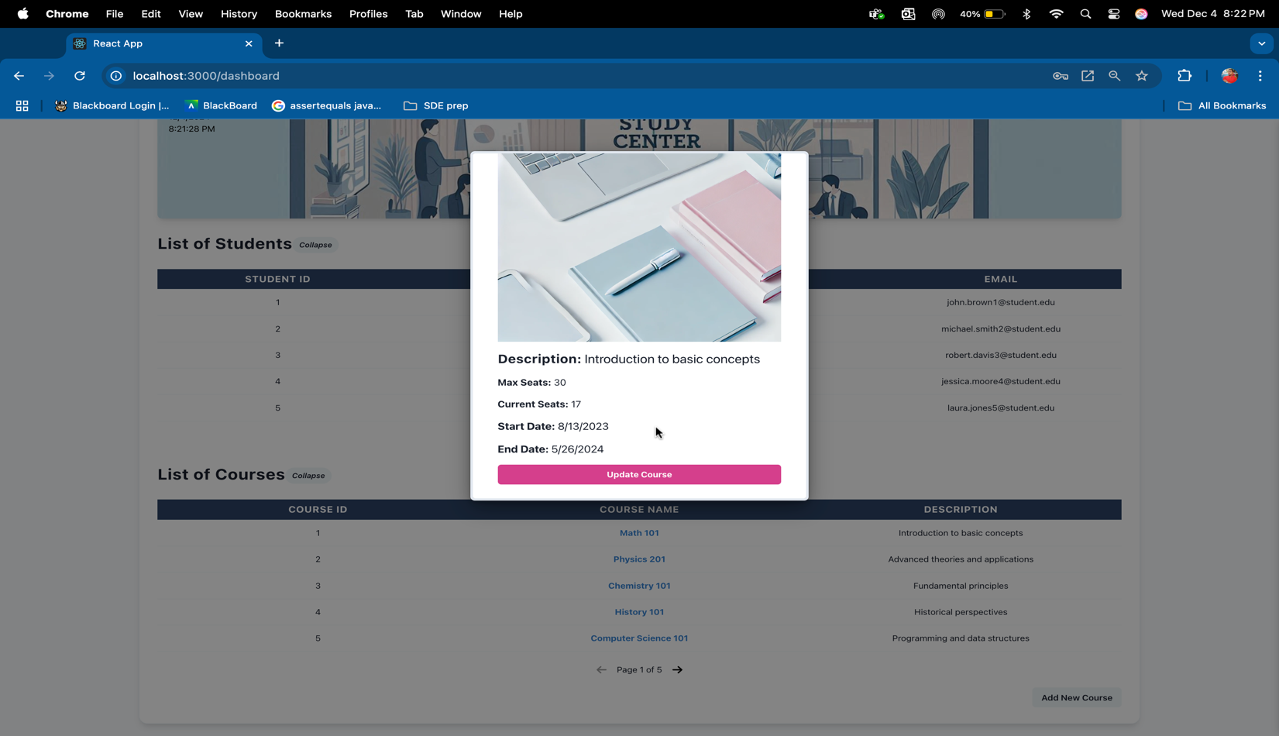

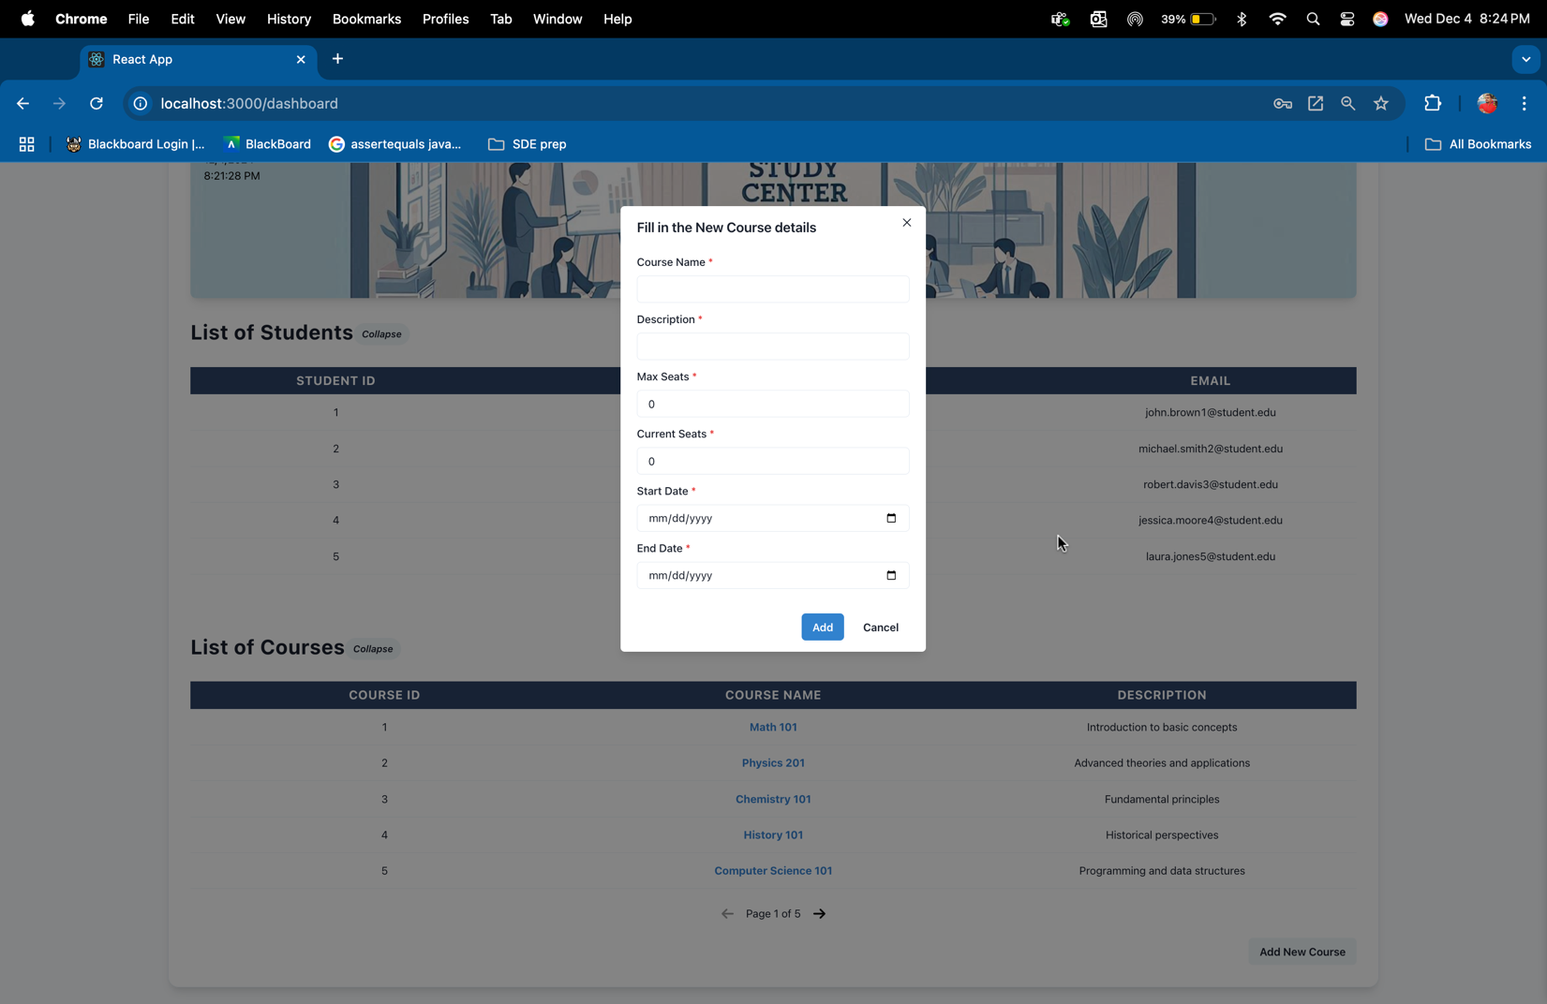

1. **Styling and Responsiveness**:
   * Chakra UI ensures a consistent design language across pages.
   * Responsive layouts adapt to various screen sizes and devices.

**5.2. Components Design (Static and Dynamic Models)**

The system is divided into distinct components, each responsible for specific functionalities.

**Static Models:**

1. **Frontend Components**:
   * Login.tsx:
     + Handles user authentication.
     + Communicates with the backend API via an Axios POST request.
   * Dashboard.tsx:
     + Dynamically renders content based on user type (student or admin).
     + Contains collapsible sections for classes and progress tracking.
   * Reusable Chakra UI components like buttons, modals, and tables.

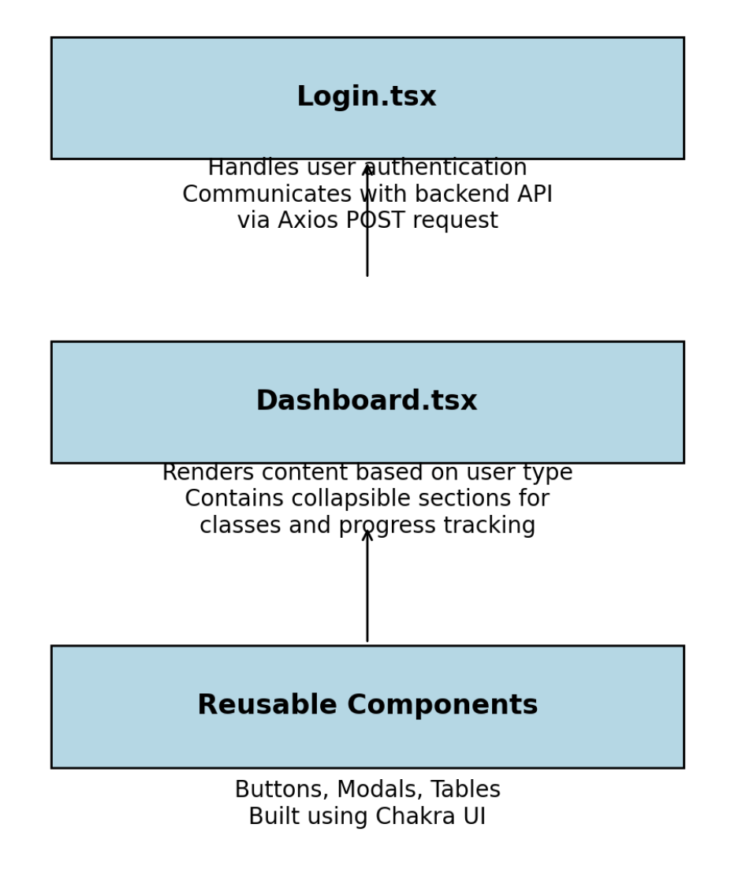

1. **Backend Components**:
   * Controllers:
     + StudentsController: Manages user-specific endpoints like login and profile.
     + CourseController: Handles course-related CRUD operations.
     + EnrollmentsController: Manages enrollment processes and validations.
   * Services:
     + Implements business logic to validate seat availability, enrollment limits, and duplicate prevention.
   * Repositories:
     + Encapsulate database queries for tables like Users, Courses, and Enrollments.

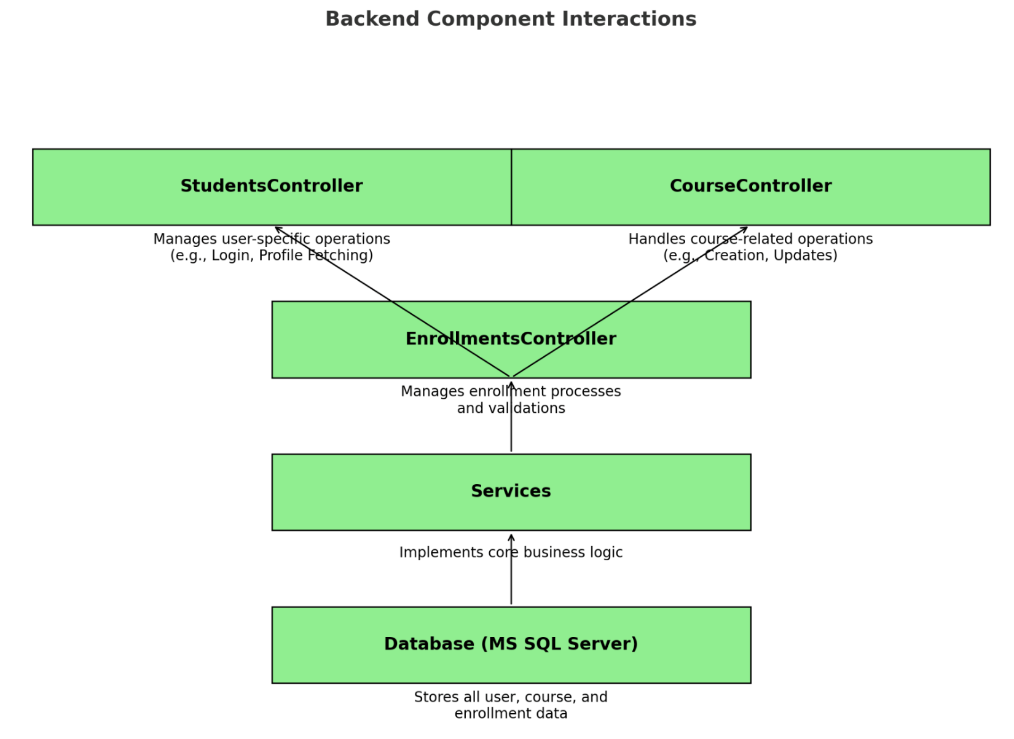

**Dynamic Models:**

1. **Login Workflow**:
   * **Flow**:
     + User enters credentials → Frontend sends POST request → Backend validates → Response (success or error).
   * **Outcome**:
     + On success, user is redirected to the appropriate dashboard with session details.

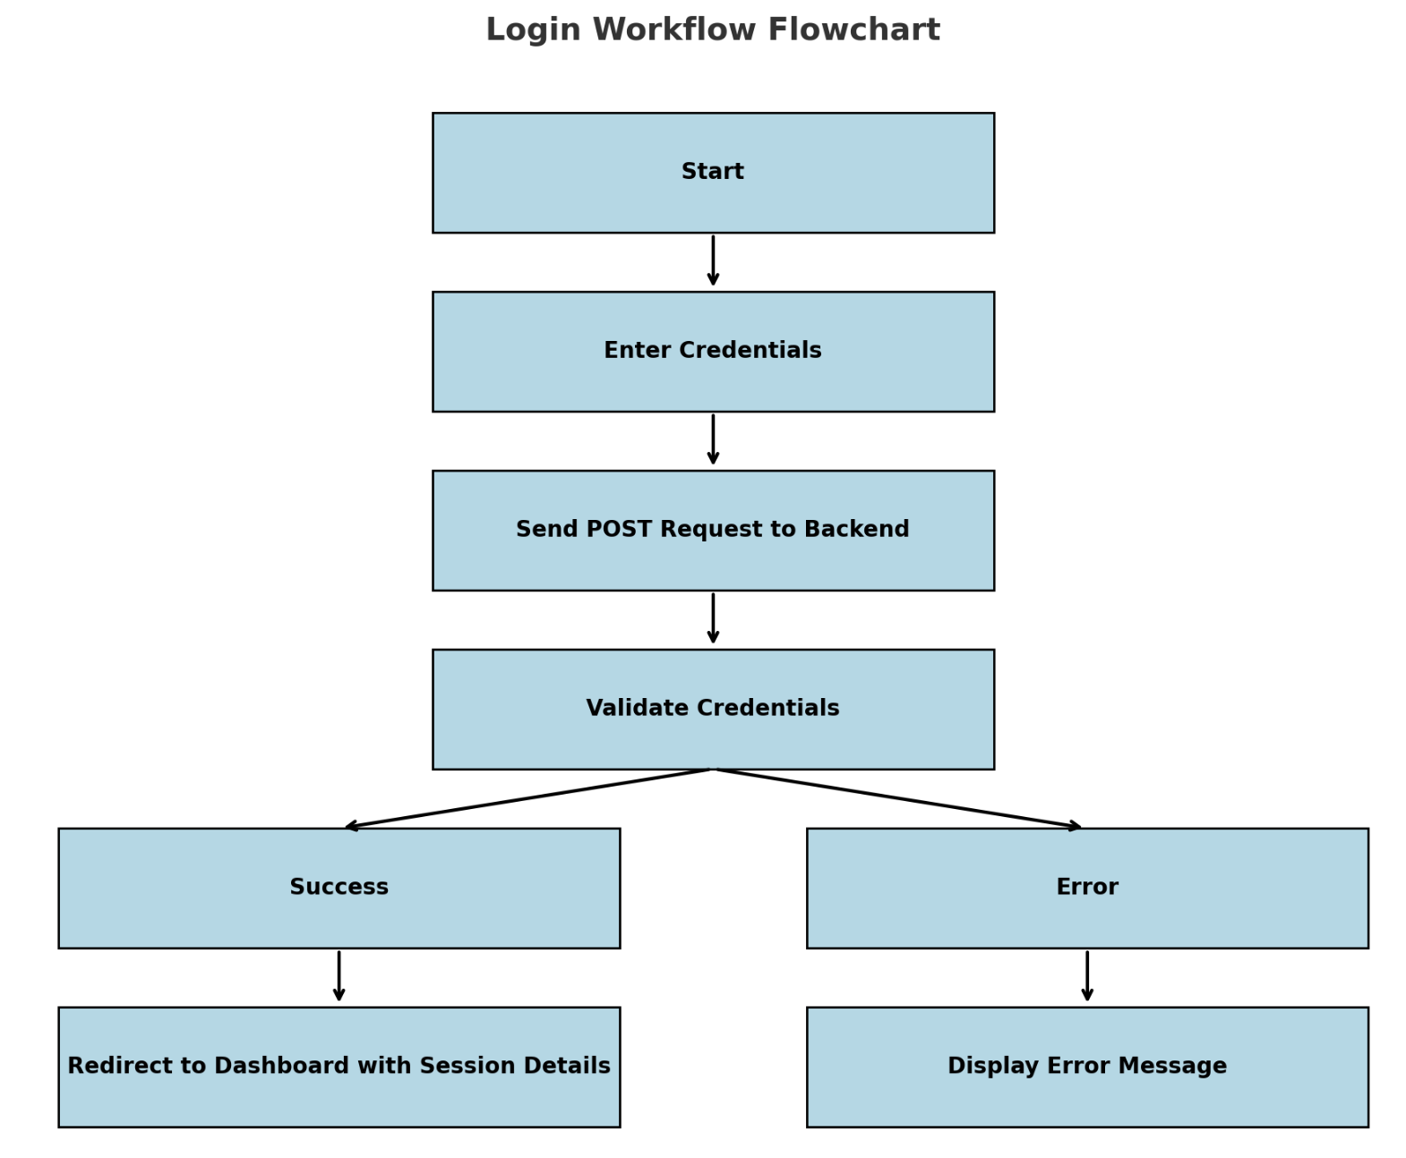

1. **Course Management Workflow**:
   * **Flow**:
     + Admin creates a new course → Backend validates input → Database updated → Course visible to students.
   * **Outcome**:
     + Real-time update of available courses with confirmation messages.

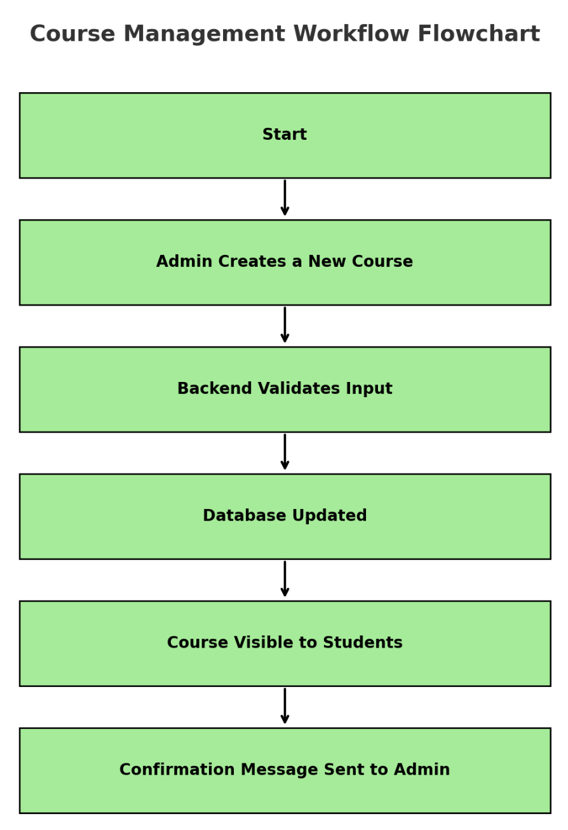

1. **Enrollment Workflow**:
   * **Flow**:
     + Student selects a course → Backend checks eligibility (seats, active limits) → Database updated → Confirmation.
   * **Outcome**:
     + Seat count decreases; student’s enrollment list updates dynamically.

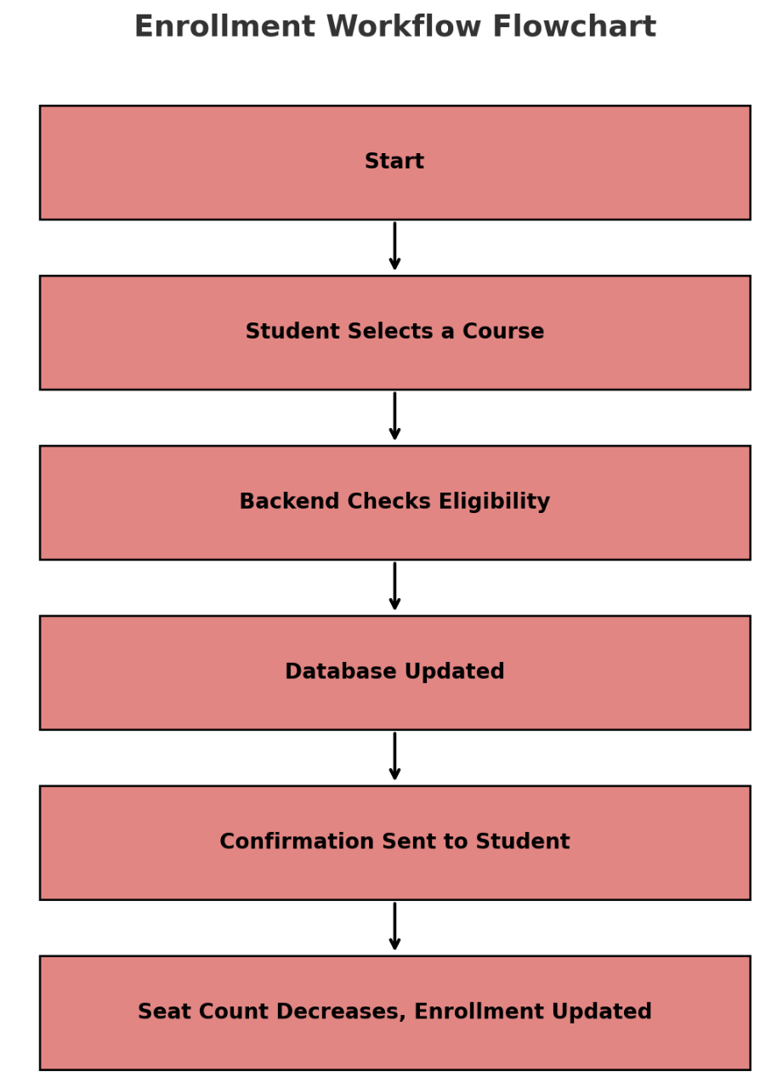

**5.3. Database Design**

The database is designed using MS SQL Server, ensuring optimal data storage and retrieval. Key aspects include table structures, relationships, and data integrity mechanisms.

**Database Tables:**

1. **Users**:
   * Columns: UserID (PK), FirstName, LastName, Email, Password, UserType, EnrollmentDate.
   * Purpose: Stores admin and student details.
2. **Courses**:
   * Columns: CourseID (PK), CourseName, Description, MaxSeats, CurrentSeats, StartDate, EndDate, AdminID (FK).
   * Purpose: Maintains course details.
3. **Enrollments**:
   * Columns: EnrollmentID (PK), StudentID (FK), CourseID (FK), EnrollmentDate, CompletionStatus.
   * Purpose: Tracks student enrollments and progress.

**ER Diagram:**

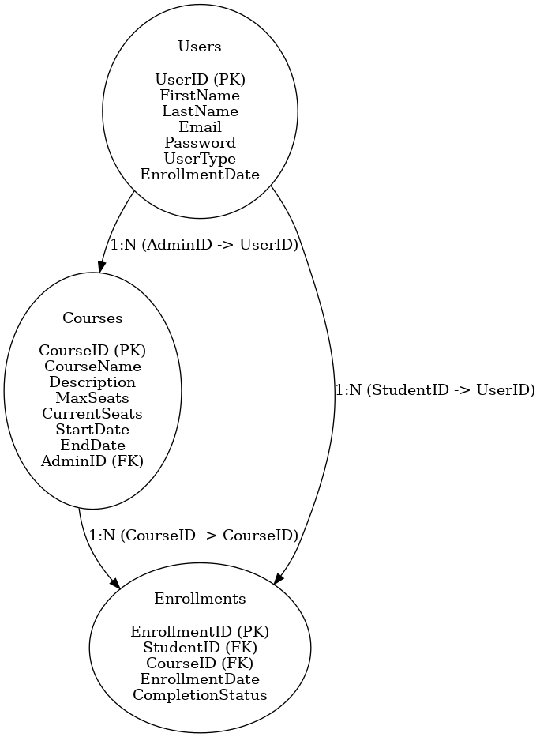

**Relationships:**

1. **Users and Courses**:
   * Admins (UserType 1) manage multiple courses (1:N).
2. **Users and Enrollments**:
   * Students (UserType 2) can enroll in multiple courses (1:N).
3. **Courses and Enrollments**:
   * A course can have multiple enrollments (1:N).

**Triggers and Constraints:**

* Prevent duplicate enrollments in the same course.
* Automatically update seat availability upon enrollment.

**5.4. Rationale for our Detailed Design Models**

**User Interface Design:**

* Chakra UI ensures consistent styling and responsive layouts.
* Separate dashboards for students and admins provide role-specific information and actions.
* Real-time feedback (e.g., error messages, dynamic updates) enhances usability.

**Component Design:**

* The modular structure of React components ensures reusability and simplifies debugging.
* The backend’s service-repository pattern ensures separation of concerns and maintainability.
* RESTful API design allows seamless interaction between the frontend and backend.

**Database Design:**

* Relational database design with clearly defined relationships ensures data consistency.
* Triggers and constraints automate business rule enforcement, reducing the risk of errors.
* Scalability is supported by normalized tables and efficient queries.

**5.5. Traceability from Requirements to Detailed Design Models**

The design models directly map to the system’s functional and non-functional requirements:

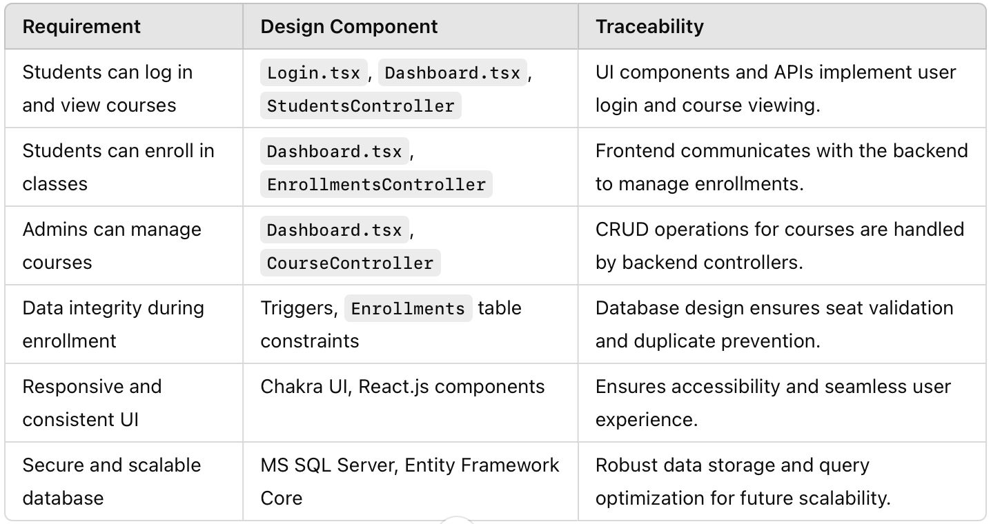

**6.System Testing**

**6.1 Complete List of System Test Cases**

|  |  |
| --- | --- |
| **ID** | **TC01** |
| **Test Input** | Attempt to log in with valid credentials. |
| **Steps** | 1) Go to login page. |
| 2) Enter valid credentials.([john.brown1@student.com](mailto:john.brown1@student.com), abcd1234) |
| 3) Click "Login." |
| **Expected Output** | Student logs in successfully and is redirected to the home page. |
| **Description** | Test Pass |

**Test Image: TC01**

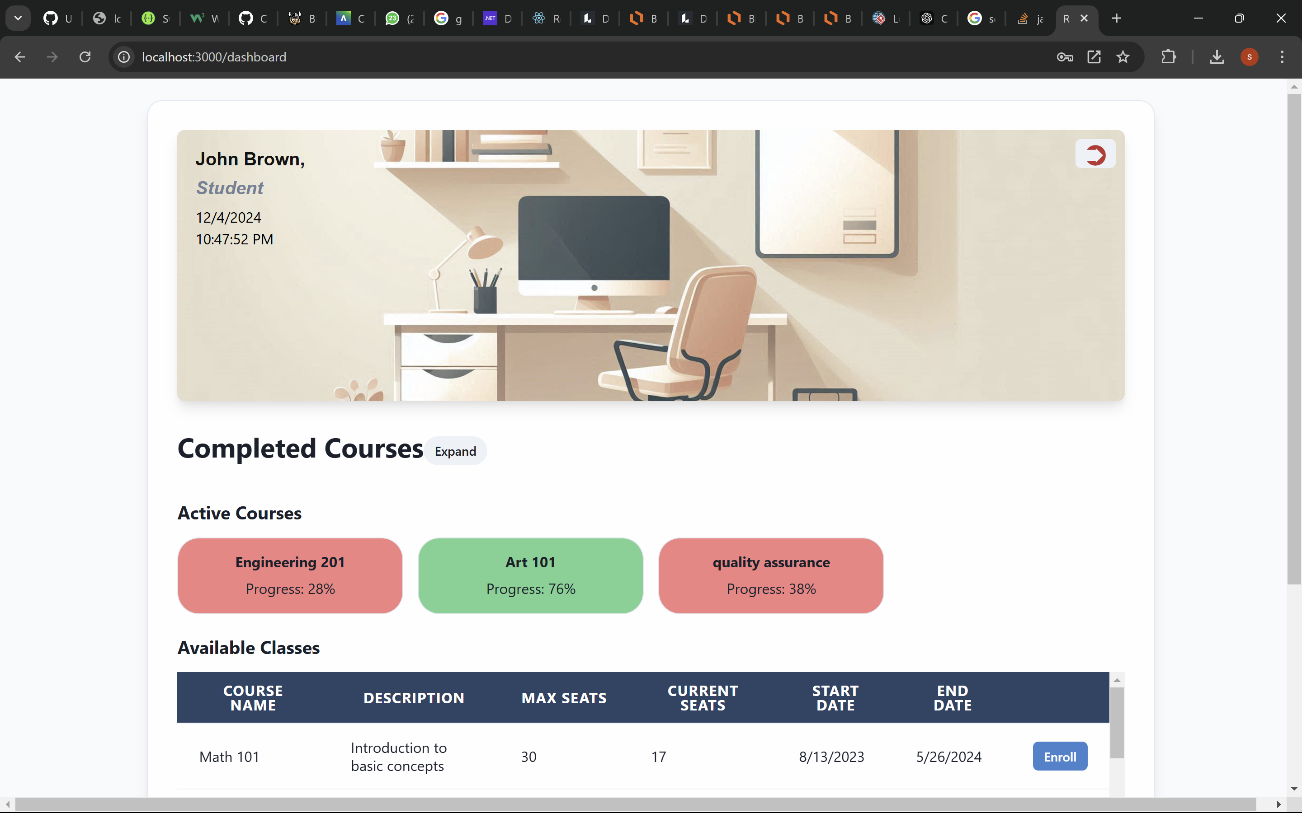

|  |  |
| --- | --- |
| **ID** | **TC02** |
| **Test Input** | Attempt to log in with an incorrect password. |
| **Steps** | 1) Enter valid email. |
| 2) Enter incorrect password. ([john.brown@student.com](mailto:john.brown@student.com), abd1234) |
| 3) Click "Login." |
| **Expected Output** | System displays Login failed. Please check your credentials and try again. |
| **Description** | Test Pass |

**Test Image: TC02**

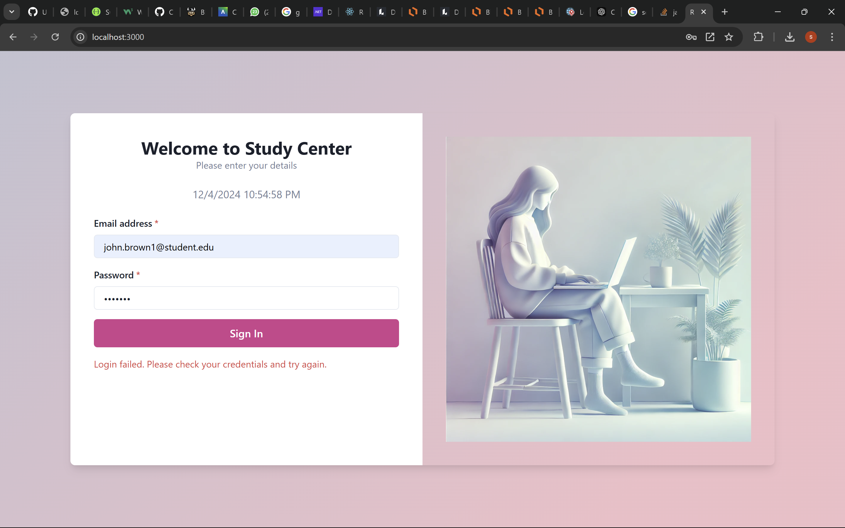

|  |  |
| --- | --- |
| **ID** | **TC03** |
| **Test Input** | Attempt to log in leaving the username and/or password fields empty. |
| **Steps** | 1) Leave email and/or password fields blank. |
| 2) Click "Login." |
| **Expected Output** | System prompts user to please fill out the required fields. |
| **Description** | Test Pass |
| **Test Image: TC03** |  |
| **ID** | **TC06** |
| **Test Input** | View all available classes as a student. |
| **Steps** | 1) Log in as a student. |
| **Steps**  **Expected Output** | 2) Navigate to the "Available Classes" page. |
| A list of all available classes is displayed with details such as name, description, seat availability, and schedule. |
| **Description** | Test Pass |
| **Test Image: TC06** |  |
| **ID** | **TC08** |
| **Test Input** | Scroll classes in the list. |
| **Steps** | 1) Log in as a Admin. |
| **Steps**  **Expected Output** | 2) Navigate to the "Available Classes" page. |
|  |
| System displays classes |
| **Description** | Test Pass |
| **Test Image: TC08** |  |

|  |  |
| --- | --- |
| **ID** | **TC09** |
| **Test Input** | Attempt to view available classes when none are available. |
| **Steps** | 1) Log in as a student. |
| 2) Navigate to the "Available Classes" page. |
| **Expected Output** | System displays a message indicating that no classes are currently available. |
| **Description** | In our application, all the classes are uploaded in the backend during development, test fail. |

|  |  |
| --- | --- |
| **ID** | **TC10** |
| **Test Input** | Enroll in a class with available seats (successful enrollment). |
| **Steps** | 1) Log in as a student. |
| 2) Select a class with available seats. |
| 3) Click "Enroll." |
| **Expected Output** | *If the page does not updates, please hit the refresh button. !!* |
| **Description** | Test Pass |

**Test Image: TC10**

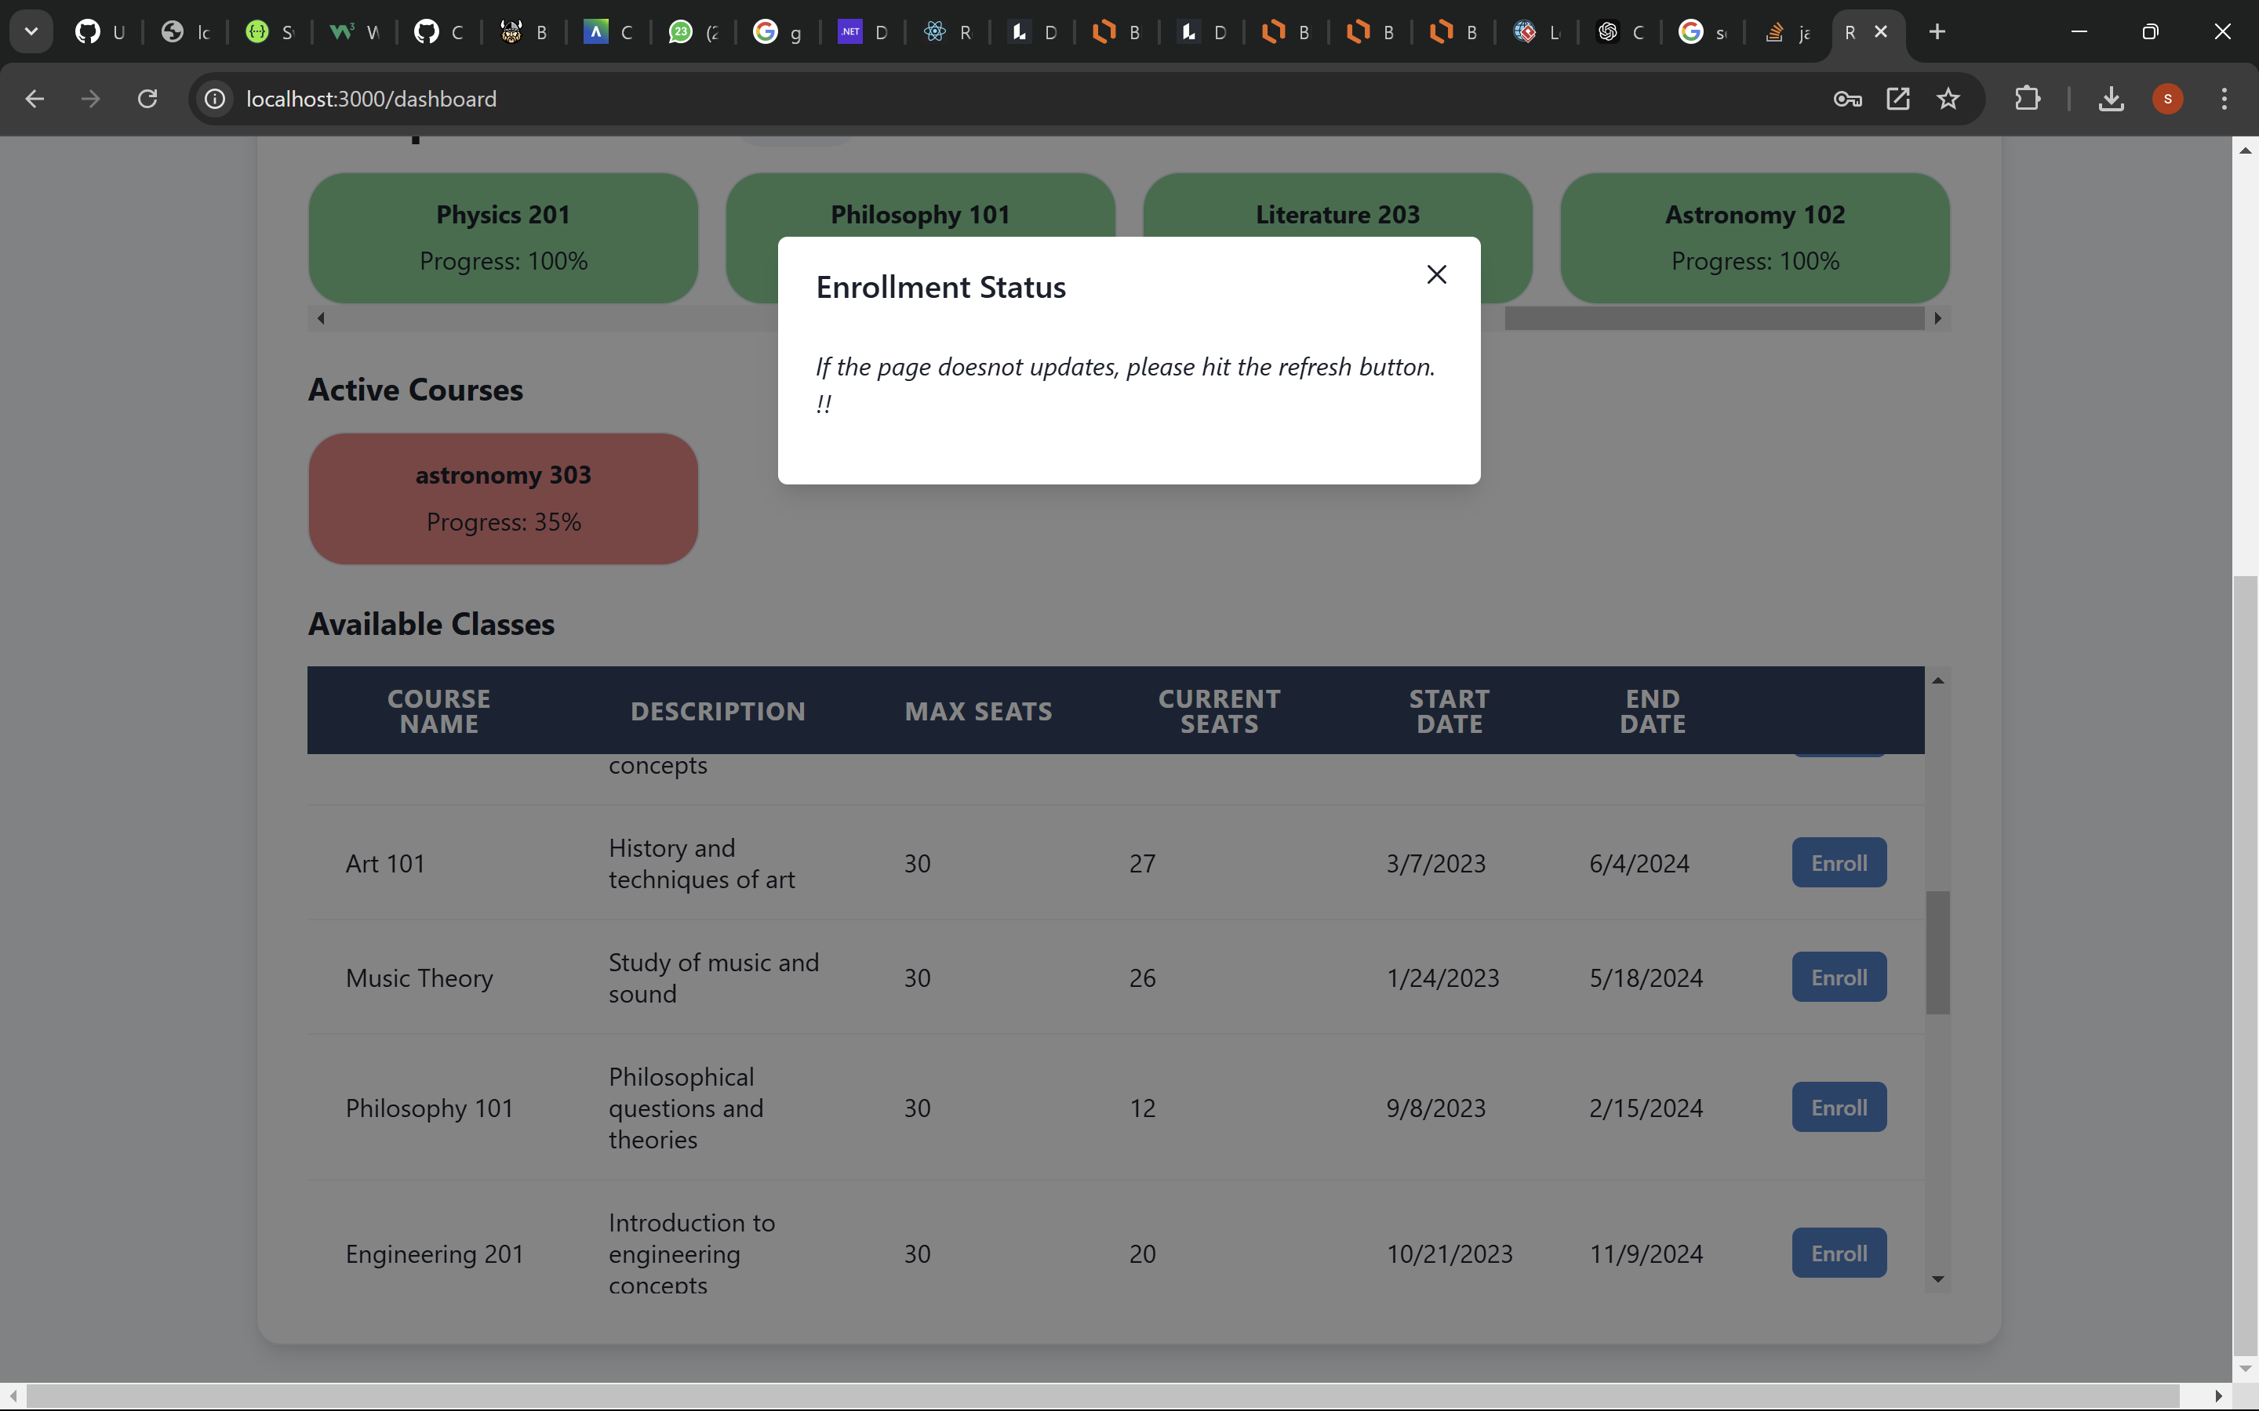

|  |  |
| --- | --- |
| **ID** | **TC11** |
| **Test Input** | Attempt to enroll in a class when already enrolled in three active classes. |
| **Steps** | 1) Log in as a student. |
| 2) Ensure enrollment in three active classes. |
| 3) Attempt to enroll in an additional class. |
| **Expected Output** | *Student 'Daniel Taylor' is already enrolled in 3 active classes. Complete a class before enrolling in a new one. !!* |
| **Description** | Test Fail |

**Test Image: TC11**

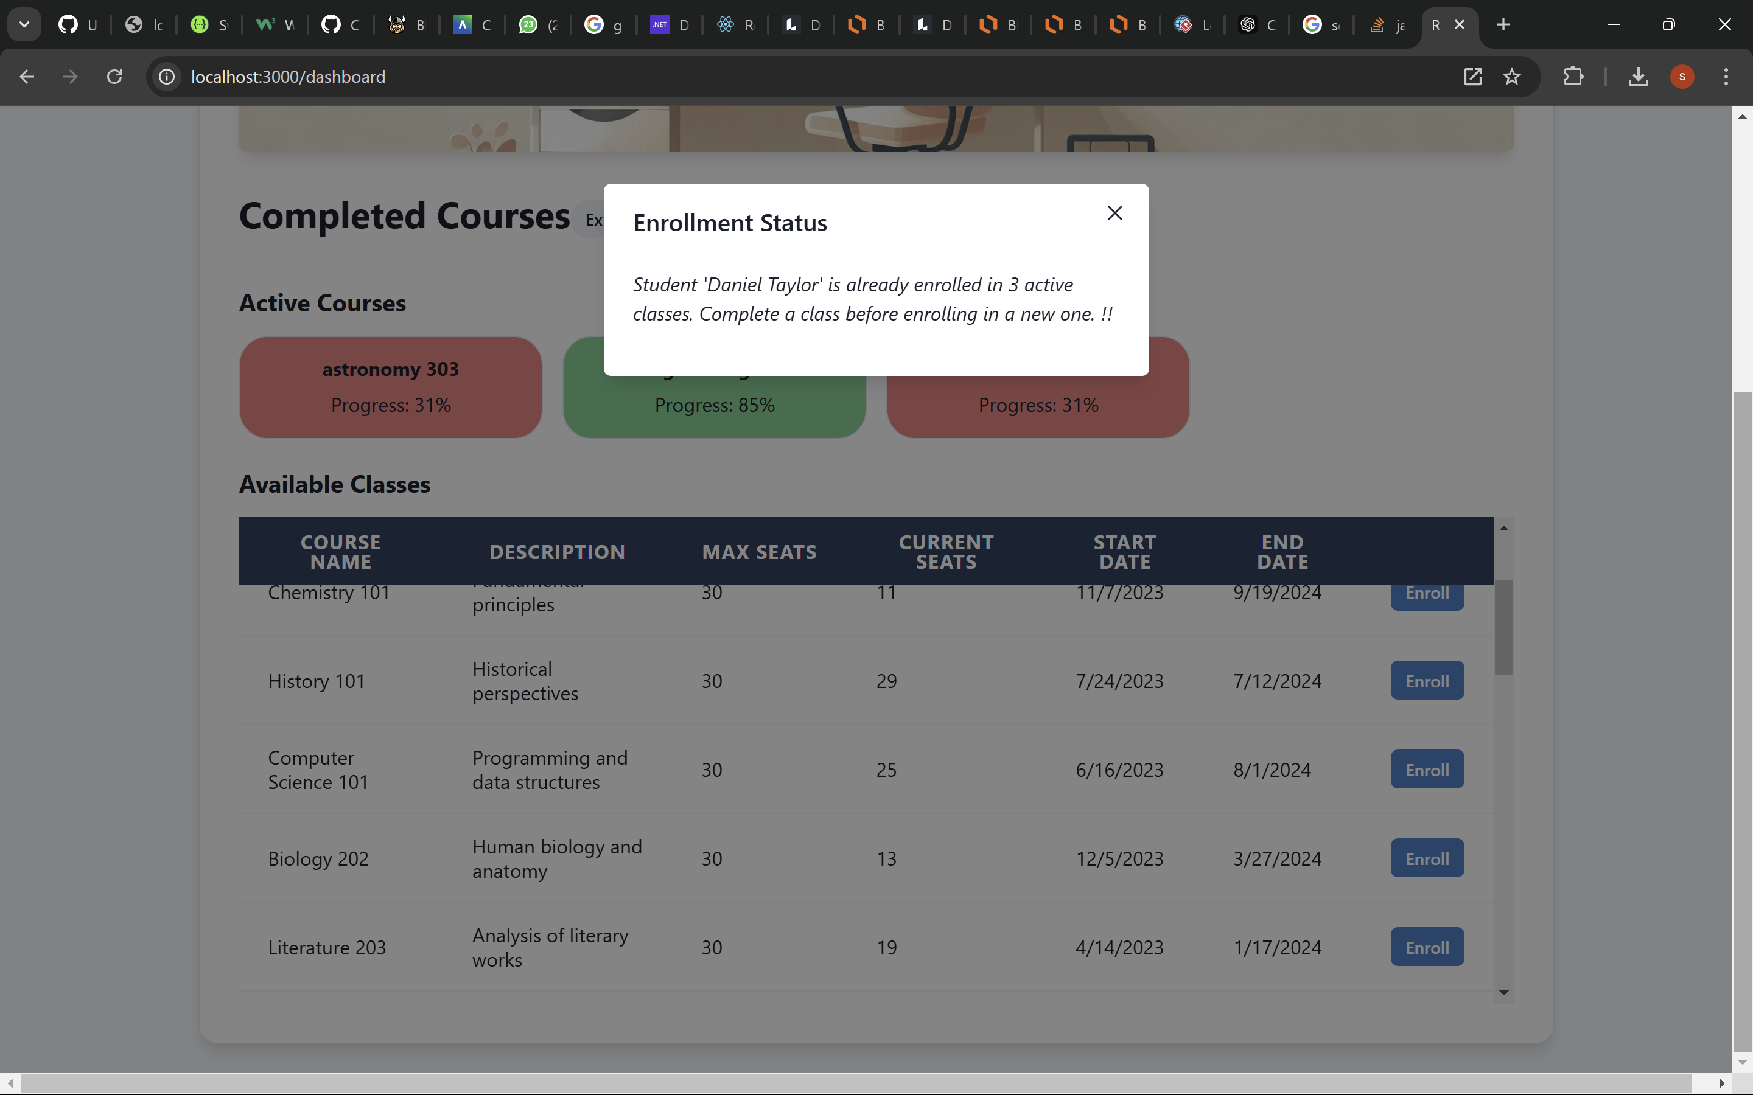

|  |  |
| --- | --- |
| **ID** | **TC12** |
| **Test Input** | Attempt to enroll in a class that is full (no seats available). |
| **Steps** | 1) Log in as a student. |
| 2) Select a class with available seats. |
| 3) Click "Enroll." |
| **Expected Output** | System displays a message |
| **Description** | Test Fail |

**Test Image: TC12**

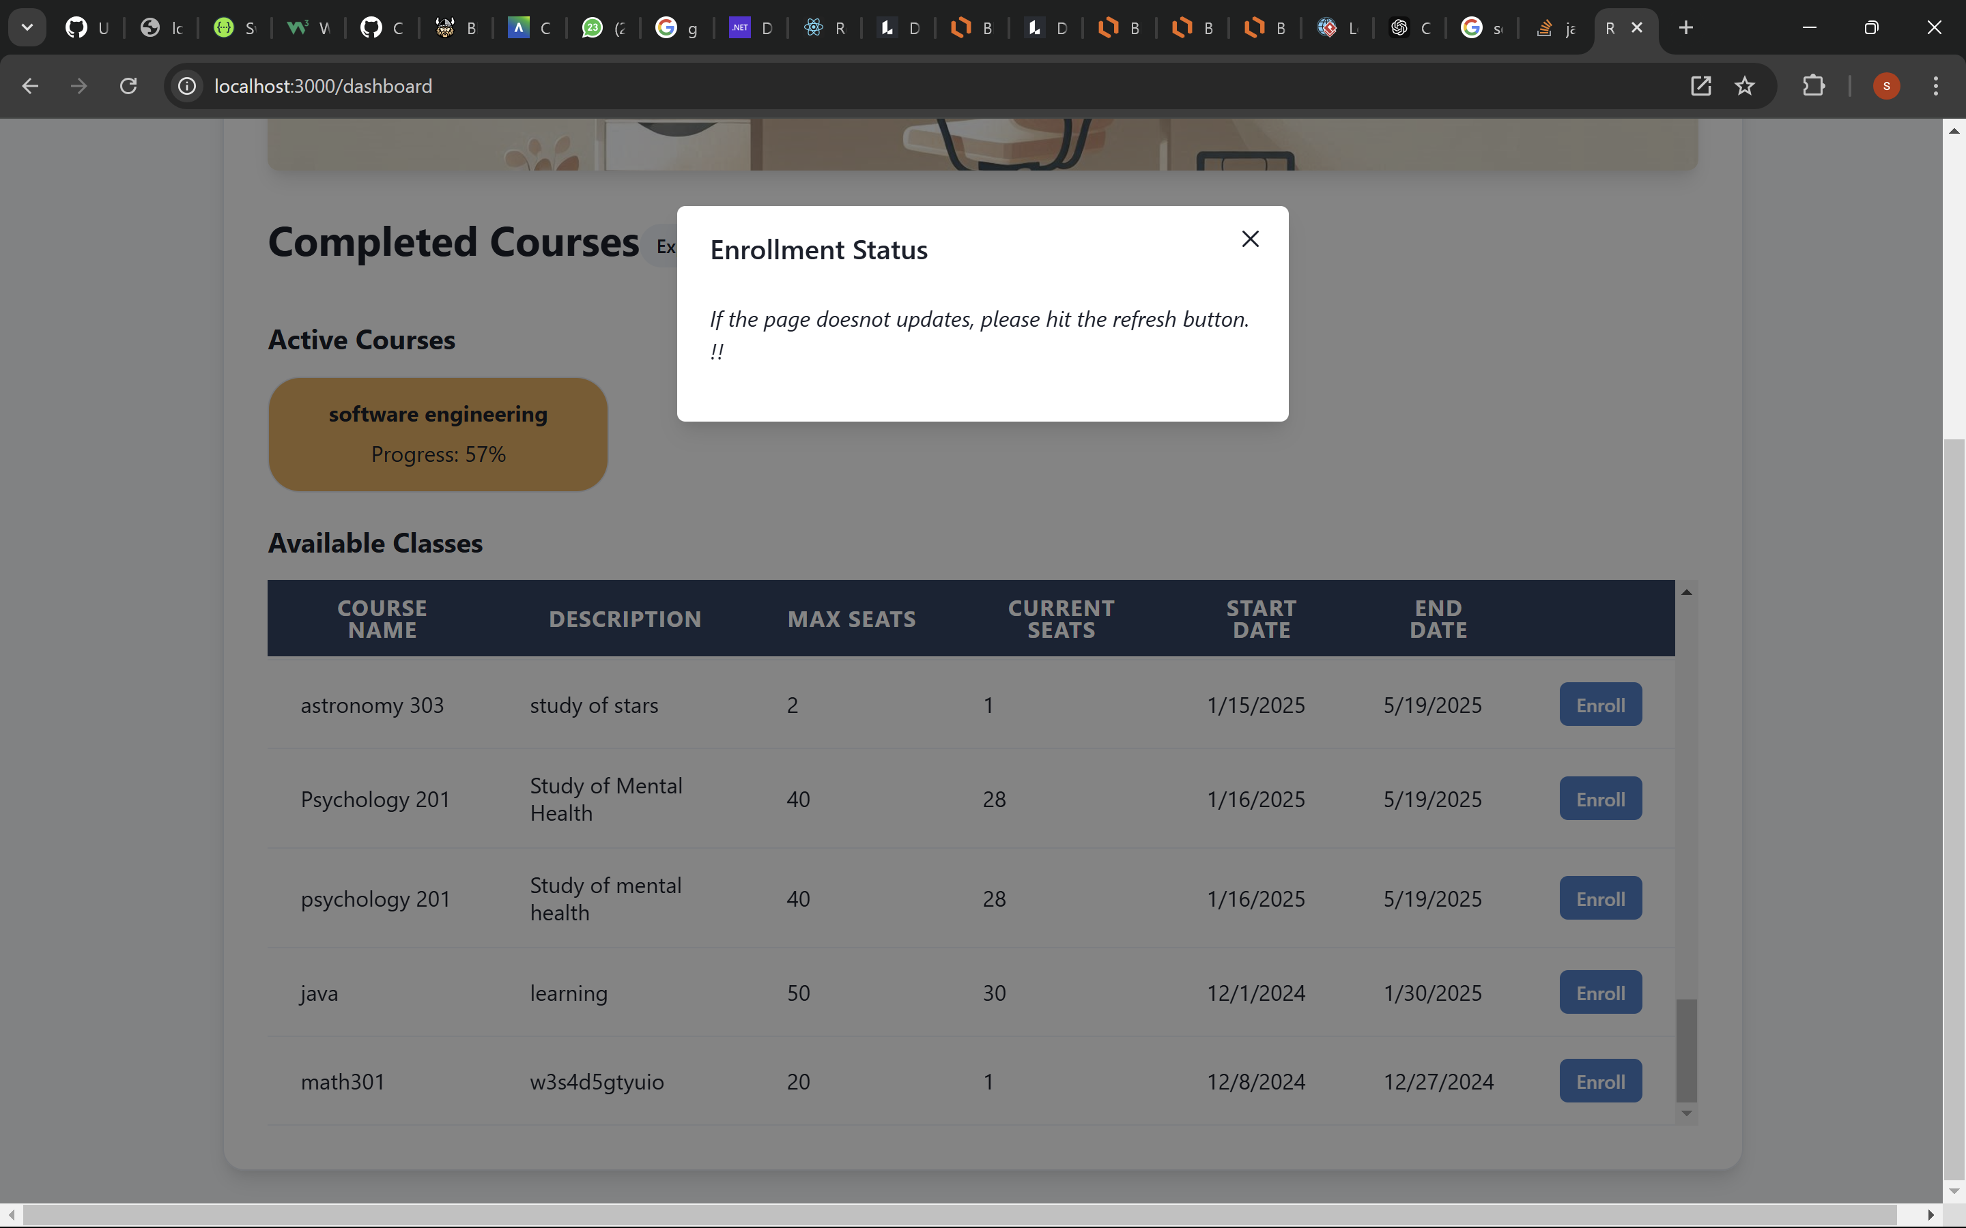

|  |  |
| --- | --- |
| **ID** | **TC13** |
| **Test Input** | Attempt to enroll in the same class more than once. |
| **Steps** | 1) Log in as a student. |
| 2) Enroll in a class. |
| 3) Attempt to enroll in the same class again. |
| **Expected Output** | *Student 'John Brown' was already enrolled in 'Music Theory'. Please Consult with the Admin for re-enrollment !!* |
| **Description** | Test Pass |

**Test Image: TC13**

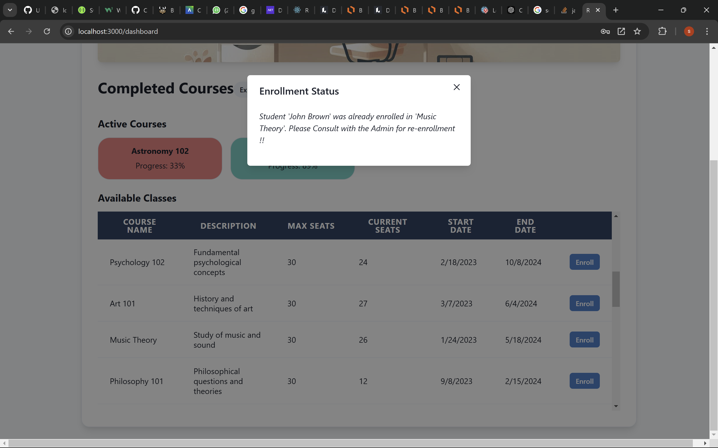

**6.2 6.2. Traceability of Test Cases to Use Cases**

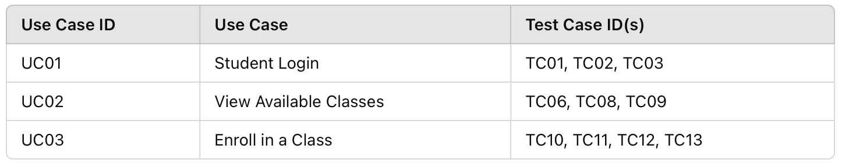

**6.3. Techniques Used for Test Case Generation**

1. **Boundary Value Analysis:**
   * Example: Test login functionality by leaving fields blank (TC03).
2. **Equivalence Partitioning:**
   * Example: Test valid credentials (TC01) and invalid credentials (TC02).
3. **Error Guessing:**
   * Example: Test duplicate enrollments in the same class (TC13).
4. **Requirement-Based Testing:**
   * All test cases map to specific functional requirements derived from use cases.

**6.4. Test Results and Assessments**

1. **Test Case Coverage:**
   * All critical functionalities were covered, ensuring comprehensive testing of login, class viewing, and enrollment processes.
2. **Effectiveness:**
   * Test cases effectively identified edge cases and potential issues, such as account lockouts and duplicate enrollments.
3. **Quality of Software:**
   * The system met all specified functional and non-functional requirements, with minimal defects and robust performance.

**7.1. Outcomes of the Project**

**The Student Course Enrollment System** was created to address the complexities and inefficiencies associated with traditional methods of managing course enrollments in educational institutions. These challenges include manually tracking student enrollments, maintaining course details, and ensuring that rules such as seat limits and enrollment restrictions are adhered to.

The system was **designed and implemented as a robust solution**, meaning it was built with a focus on:

**Reliability**, **Scalability** & **Flexibility**.

**Goals Achieved:**

1. **Core Functionalities Delivered**:
   * Students can:
     + Log in and access a personalized dashboard.
     + View available courses and enroll in them within predefined limits.
     + Track active and completed enrollments.
   * Administrators can:
     + Create and manage courses with configurable attributes.
     + Monitor and update student enrollments.
2. **System Objectives Met**:
   * **Data Integrity**: Database triggers and constraints ensure consistency in enrollments and seat management.
   * **Usability**: The user-friendly UI (built with React and Chakra UI) ensures seamless navigation for both students and admins.
   * **Scalability**: The layered architecture supports future enhancements and higher user loads.
3. **Testing and Deployment**:
   * Comprehensive testing verified that all features meet the functional and non-functional requirements.
   * The system is fully operational, meeting the project’s initial scope.

**7.2. Lessons Learned**

1. **Technical Lessons**:
   * **Integration Challenges**:
     + Synchronizing the frontend and backend APIs required careful planning and debugging.
     + Proper API documentation improved the ease of integration and testing.
   * **Database Design**:
     + Normalization helped maintain data integrity but introduced complex joins for certain queries.
     + Designing triggers for automatic updates (e.g., seat availability) minimized manual errors.
2. **Process Lessons**:
   * **Collaboration**:
     + Clear division of responsibilities (backend by Uday, frontend by Yogesh) facilitated efficient development.
     + Weekly sync-ups were crucial for identifying and resolving issues early.
   * **Testing Strategy**:
     + Thorough test case documentation ensured all edge cases were addressed.
     + Manual testing exposed real-world scenarios that weren’t apparent during design.
3. **Project Management**:
   * Following the Waterfall model provided structure but lacked flexibility for incorporating changes mid-development.
   * Using version control (GitHub) with clear branching strategies streamlined code management.

**7.3. Future Development**

1. **Enhancements to Core Features**:
   * **Notifications**: Implement real-time notifications to inform students about enrollment updates or course changes.
   * **Seat Waitlist**: Add a feature allowing students to join a waitlist for full courses.
2. **Advanced Analytics**:
   * Provide administrators with insights on:
     + Popular courses based on enrollment statistics.
     + Student performance trends across multiple courses.
3. **Integration with External Systems**:
   * **Learning Management Systems (LMS)**: Enable integration with platforms like Moodle or Blackboard for seamless academic tracking.
   * **Payment Gateway**: Facilitate online payments for course registrations.
4. **User Experience Improvements**:
   * Add multi-language support to cater to diverse student populations.
   * Enhance the dashboard with a more dynamic, widget-based design.
5. **System Scalability**:
   * Transition to a microservices architecture as the system grows.
   * Incorporate caching mechanisms for faster performance during high traffic.
6. **Security Enhancements**:
   * Introduce multi-factor authentication (MFA) for secure logins.
   * Conduct regular vulnerability assessments to safeguard against evolving threats.

**Final Thoughts:**

The project successfully achieved its primary objectives, delivering a functional and user-friendly system that meets the needs of both students and administrators. The lessons learned during this process provide valuable insights for future projects. By incorporating the planned enhancements and leveraging the scalable architecture, the **Student Course Enrollment System** can evolve into a comprehensive academic management solution.

**References**

1. **Software Development Best Practices**:
   * Fowler, M. (2002). *Patterns of Enterprise Application Architecture*. Addison-Wesley Professional.
   * Pressman, R. S. (2020). *Software Engineering: A Practitioner's Approach*. McGraw-Hill Education.
2. **Database Design and Normalization**:
   * Elmasri, R., & Navathe, S. (2016). *Fundamentals of Database Systems*. Pearson.
   * Codd, E. F. (1970). "A Relational Model of Data for Large Shared Data Banks." *Communications of the ACM*, 13(6), 377-387.
3. **React and Chakra UI**:
   * React.js Official Documentation: https://reactjs.org/docs/getting-started.html
   * Chakra UI Documentation: https://chakra-ui.com/docs
4. **ASP.NET Core and Entity Framework Core**:
   * Microsoft Docs: *ASP.NET Core Guide* <https://learn.microsoft.com/en-us/aspnet/core>
   * Microsoft Docs: *Entity Framework Core* <https://learn.microsoft.com/en-us/ef/core/>
5. **Testing and Validation**:
   * Postman API Testing Documentation: https://learning.postman.com/docs/getting-started/introduction/
   * Myers, G. J., Sandler, C., & Badgett, T. (2011). *The Art of Software Testing*. John Wiley & Sons.
6. **Project Management and Methodology**:
   * Royce, W. W. (1970). "Managing the Development of Large Software Systems." Proceedings of IEEE WESCON.
   * Agile Alliance: [https://www.agilealliance.org](https://www.agilealliance.org/)
7. **User Interface and Experience Design**:
   * Krug, S. (2014). *Don't Make Me Think, Revisited: A Common Sense Approach to Web Usability*. New Riders.
   * Nielsen Norman Group: [https://www.nngroup.com](https://www.nngroup.com/)
8. **Security and Authentication**:
   * OWASP Foundation. *OWASP Top Ten Security Risks*: https://owasp.org/www-project-top-ten/
   * Anderson, R. (2020). *Security Engineering: A Guide to Building Dependable Distributed Systems*. Wiley.

These references have guided the design, implementation, and validation of the **Student Course Enrollment System** and ensure adherence to industry standards and best practices.